Twentieth Sunday after Trinity
Sunday, October 30th, 2022
Divine Service 3, Page 184
LARGE PRINT

Divine Shepherd Lutheran Church & School

7308 Wedgewood Drive
Black Hawk, SD 57718
“We are baptized children of God, forgiven and redeemed by Jesus. We are His family, called together to receive His gifts and serve others.”
Pastor Randy Sturzenbecher
Vicar Dennis Mercer
Office 787-6438 Pastor Cell 391-0428
ECC 791-1131

Email: DSLCPastor@divineshep.org
DSLCVicar@divineshep.org
DSLCSecretary@divineshep.org

Greetings to all in the Name of the Risen Lord!
May our worship celebrate the joy and hope, peace and presence, of our Lord Jesus Christ, raised to life for us. We welcome all, especially our guests. If you do not have a church home please consider Divine Shepherd. We would love to have you as part of our family. Please take a minute and sign our guest book.

A prayer before Worship
This is the day you have made, O Lord Jesus, a day of new life and eternal celebration! The stone is moved; death is defeated; heaven is open. As Your disciples first saw and believed Your victory over the tomb, so give us joy in the promise You made and keep for us: because You live, we live also! Amen.

The Lord’s Supper
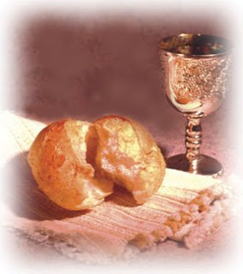
The Lord’s Supper is celebrated in the confession and gladness that, as our Lord says, He gives into our mouth not only bread and wine but His very body and blood to eat and drink for the forgiveness of sins and to strengthen our union with Him and with one another. Our Lord Jesus invites to His table those who trust His Words, repent of all sin, and set aside any refusal to forgive and love as He forgives and loves us, that they may show forth His death until He comes.

Whoever, therefore, eats the bread or drinks the blood of the Lord in an unworthy manner will be guilty concerning the body and blood of the Lord.
(1 Cor 11:28 ESV) Holy Communion is a confession of the faith which is confessed at this altar. Any who holds a confession differing from that of the Holy Scriptures, or are not a member in good standing with the LC-MS, are asked to speak with Pastor Sturzenbecher.

Members and guests of DSLC and School we stream our services through Facebook Live. With this stream we do publish this to our Facebook page which means your face may end up on our Facebook page. If you are not comfortable with this please talk to Pastor to address this concern. -Thank you, The AV Team.

645 Built on the Rock
1 Built on the Rock the Church shall stand
Even when steeples are falling.
Crumbled have spires in ev’ry land;
Bells still are chiming and calling,
Calling the young and old to rest,
But above all the souls distressed,
Longing for rest everlasting.

2 Surely in temples made with hands
God, the Most High, is not dwelling;
High above earth His temple stands,
All earthly temples excelling.
Yet He who dwells in heav’n above
Chooses to live with us in love,
Making our bodies His temple.

3 We are God’s house of living stones,
Built for His own habitation.
He through baptismal grace us owns
Heirs of His wondrous salvation.
Were we but two His name to tell,
Yet He would deign with us to dwell
With all His grace and His favor.

4 Here stands the font before our eyes,
Telling how God has received us.
The_altar recalls Christ’s sacrifice
And what His Supper here gives us.
Here sound the Scriptures that proclaim
Christ yesterday, today, the same,
And evermore, our Redeemer.

5 Grant, then, O God, Your will be done,
That, when the church bells are ringing,
Many in saving faith may come
Where Christ His message is bringing:
“I know My own; My own know Me.
You, not the world, My face shall see.
My peace I leave with you. Amen.”
Text: Nikolai Fredrik Severin Grundtvig, 1783–1872, abr.; tr. Carl Döving, 1867–1937, alt.
Text: Public domain

Invocation & Exhortation
P In the name of the Father and of the + Son and of the Holy Spirit.
C Amen.
C who made heaven and earth.
P I said, I will confess my transgressions unto the Lord,
C and You forgave the iniquity of my sin.

Confession and Absolution
P O almighty God, merciful Father,
C I, a poor, miserable sinner, confess unto You all my sins and iniquities with which I have ever offended You and justly deserved Your temporal and eternal punishment. But I am heartily sorry for them and sincerely repent of them, and I pray You of Your boundless mercy and for the sake of the holy, innocent, bitter sufferings and death of Your beloved Son, Jesus Christ, to be gracious and merciful to me, a poor, sinful being.
C Amen.

Introit Psalm 48:1, 9–11
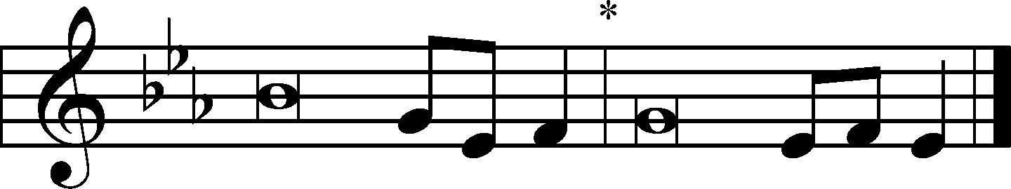
The Lord is righteous in all he has | done to us,*
for we have not obeyed his com- | mandments.
Glorify your name, | O Lord;*
and deal with us according to your great | mercy.
Great is the Lord and greatly | to be praised*
in the city of our God, his holy | mountain.
We have thought on your steadfast love, | O God,*
in the midst of your | temple.
As your name, O God, so your praise reaches to the ends | of the earth.*
Your right hand is filled with | righteousness.
Let Mount Zion | be glad!*
Let the daughters of Judah rejoice because of your | judgments!
Glory be to the Father and | to the Son*
and to the Holy | Spirit;
as it was in the be- | ginning,*
is now, and will be forever. | Amen.
The Lord is righteous in all he has | done to us,*
for we have not obeyed his com- | mandments.
Glorify your name, | O Lord;*
and deal with us according to your great | mercy.
Gloria Patri
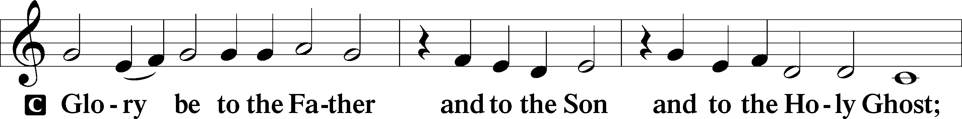
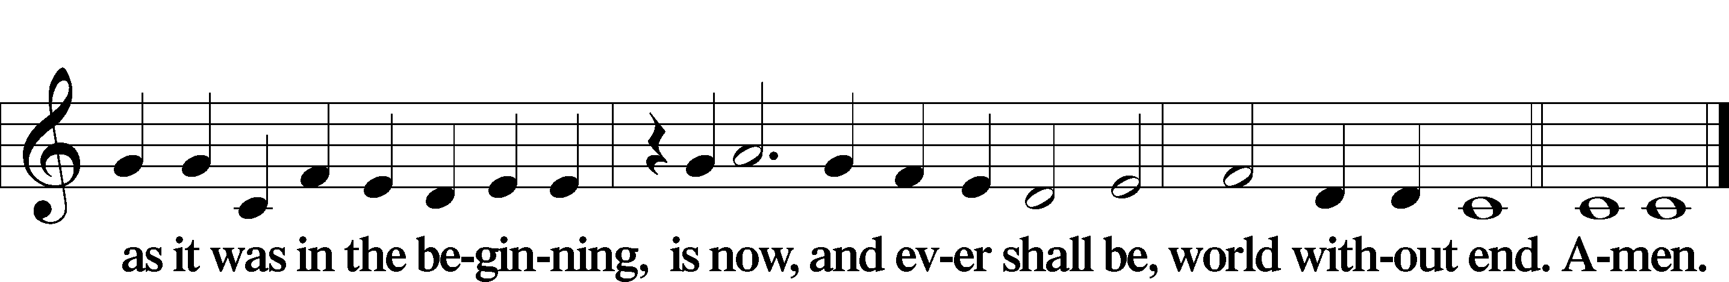
Kyrie LSB 186
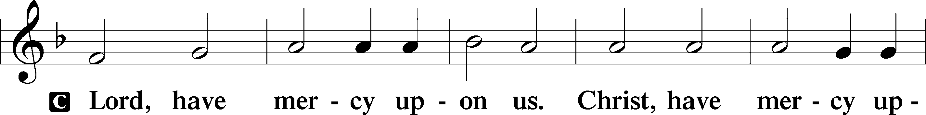
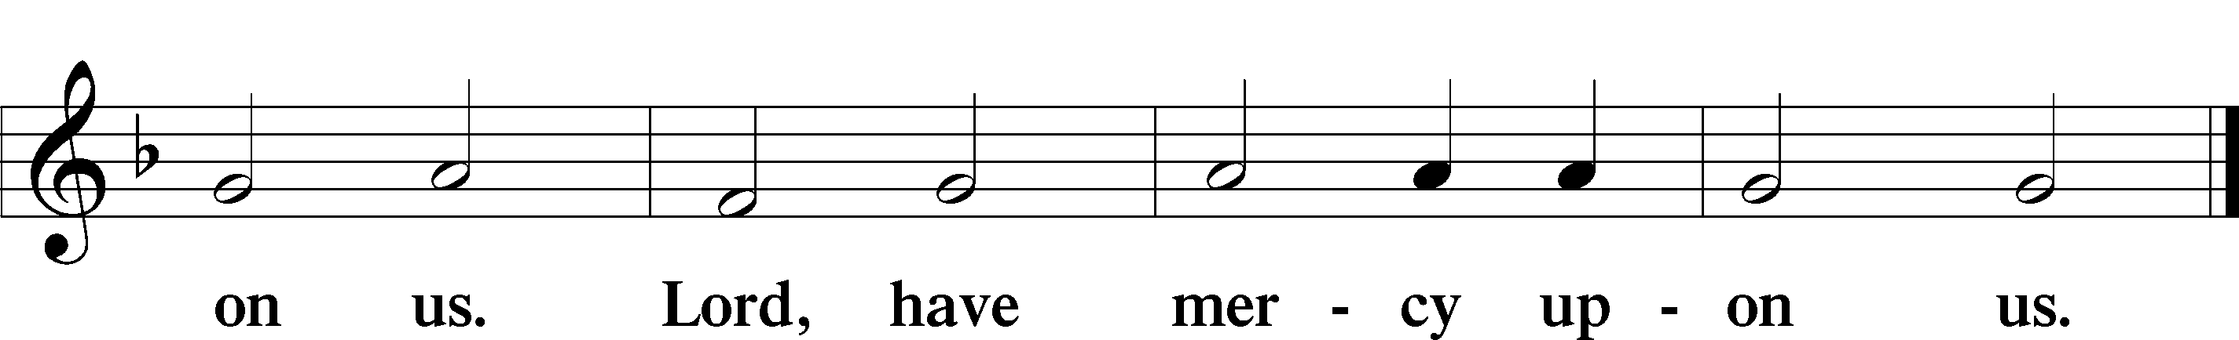

Gloria in Excelsis LSB 187
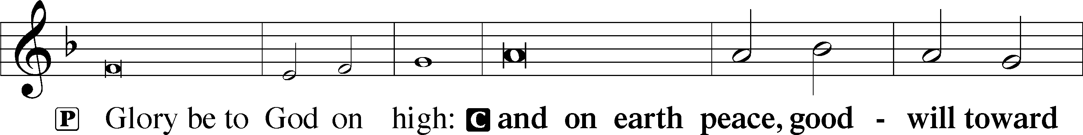
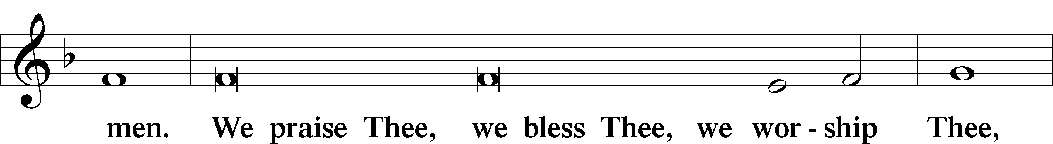
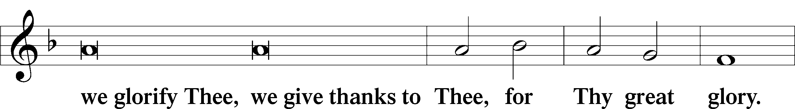
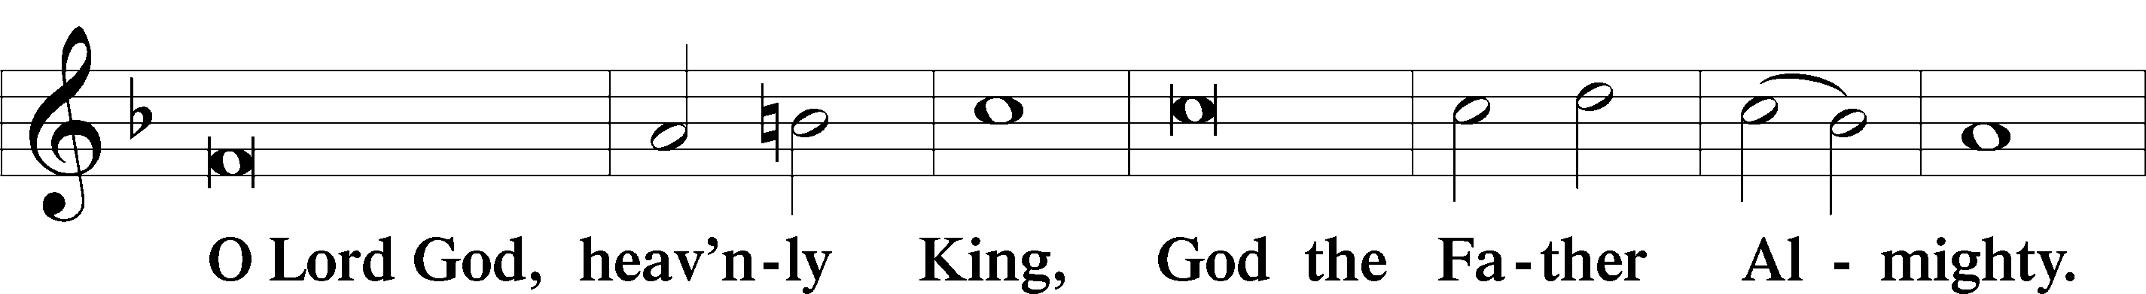
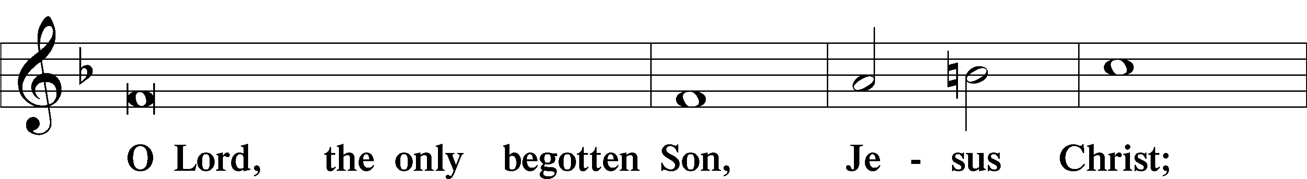
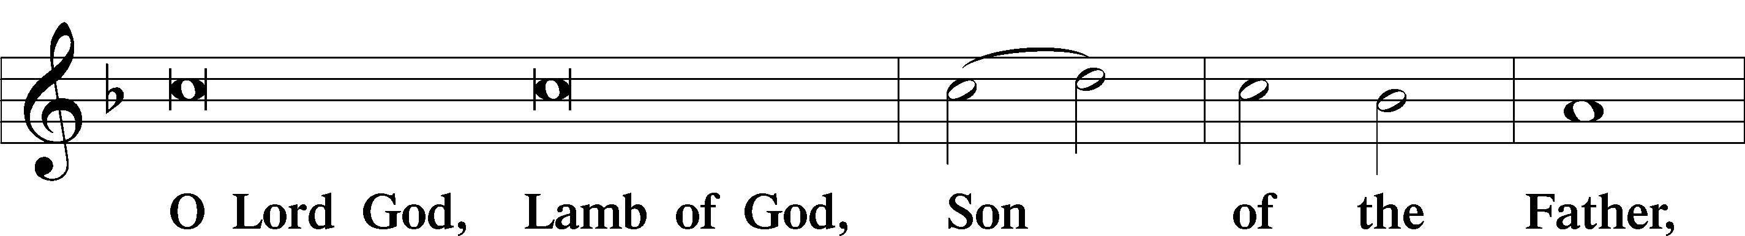
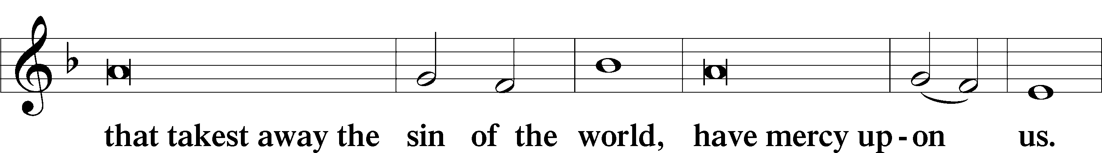
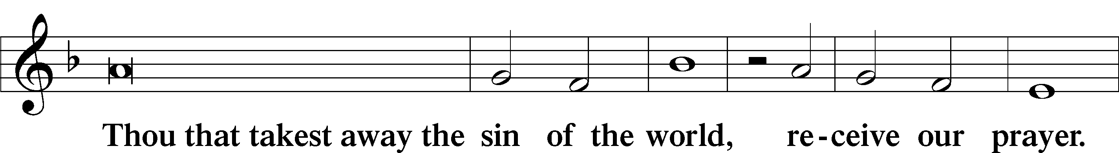
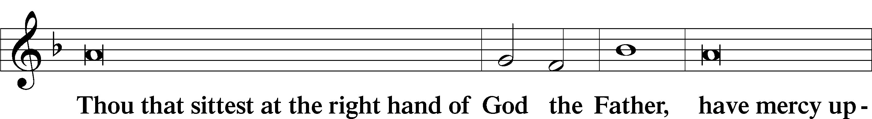
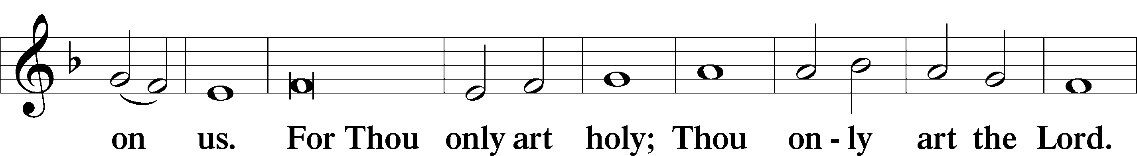
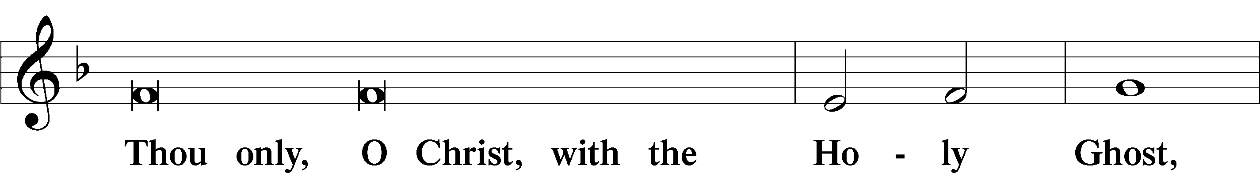
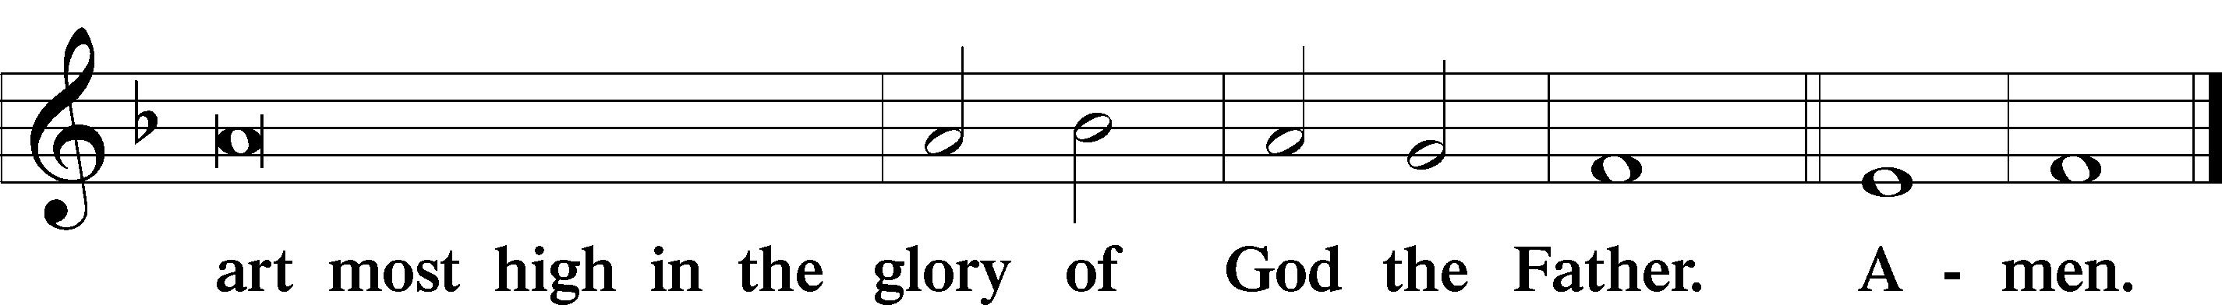

Salutation and Collect of the Day

Old Testament Reading Isaiah 55:1–9
¹“Come, everyone who thirsts,
come to the waters;
and he who has no money,
come, buy and eat!
Come, buy wine and milk
without money and without price.
²Why do you spend your money for that which is not bread,
and your labor for that which does not satisfy?
Listen diligently to me, and eat what is good,
and delight yourselves in rich food.
³Incline your ear, and come to me;
hear, that your soul may live;
and I will make with you an everlasting covenant,
my steadfast, sure love for David.
⁴Behold, I made him a witness to the peoples,
a leader and commander for the peoples.
⁵Behold, you shall call a nation that you do not know,
and a nation that did not know you shall run to you,
because of the Lord your God, and of the Holy One of Israel,
for he has glorified you.
⁶“Seek the Lord while he may be found;
call upon him while he is near;
⁷let the wicked forsake his way,
and the unrighteous man his thoughts;
let him return to the Lord, that he may have compassion on him,
and to our God, for he will abundantly pardon.
⁸For my thoughts are not your thoughts,
neither are your ways my ways, declares the Lord.
⁹For as the heavens are higher than the earth,
so are my ways higher than your ways
and my thoughts than your thoughts.”

Catechetical Review
The Second Article
Redemption
And in Jesus Christ, His only Son, our Lord, who was conceived by the Holy Spirit, born of the virgin Mary, suffered under Pontius Pilate, was crucified, died and was buried. He descended into hell. The third day He rose again from the dead. He ascended into heaven and sits at the right hand of God the Father Almighty. From thence He will come to judge the living and the dead.

What does this mean?
I believe that Jesus Christ, true God, begotten of the Father from eternity, and also true man, born of the virgin Mary, is my Lord,

who has redeemed me, a lost and condemned person, purchased and won me from all sins, from death, and from the power of the devil; not with gold or silver, but with His holy, precious blood and with His innocent suffering and death,

that I may be His own and live under Him in His kingdom and serve Him in everlasting righteousness, innocence, and blessedness,

just as He is risen from the dead, lives and reigns to all eternity.

This is most certainly true.

Epistle Ephesians 5:15–21
¹⁵Look carefully then how you walk, not as unwise but as wise, ¹⁶making the best use of the time, because the days are evil. ¹⁷Therefore do not be foolish, but understand what the will of the Lord is. ¹⁸And do not get drunk with wine, for that is debauchery, but be filled with the Spirit, ¹⁹addressing one another in psalms and hymns and spiritual songs, singing and making melody to the Lord with all your heart, ²⁰giving thanks always and for everything to God the Father in the name of our Lord Jesus Christ, ²¹submitting to one another out of reverence for Christ.

Alleluia LSB 190
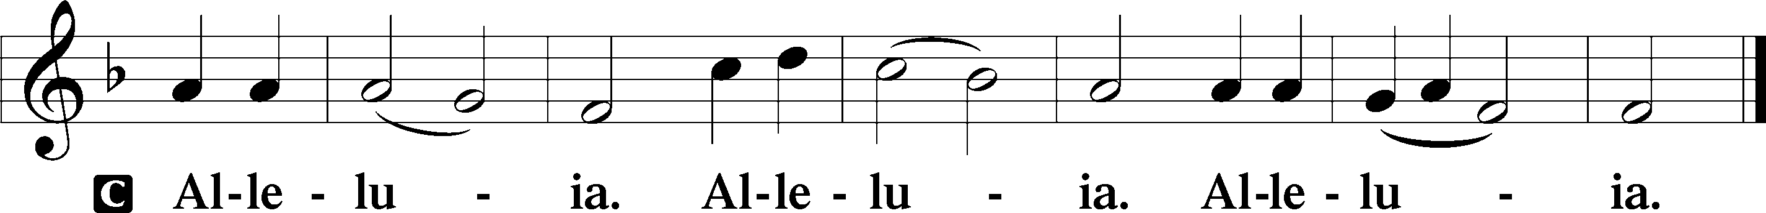

Holy Gospel Matthew 22:1–14
¹Again Jesus spoke to them in parables, saying, ²“The kingdom of heaven may be compared to a king who gave a wedding feast for his son, ³and sent his servants to call those who were invited to the wedding feast, but they would not come. ⁴Again he sent other servants, saying, ‘Tell those who are invited, See, I have prepared my dinner, my oxen and my fat calves have been slaughtered, and everything is ready. Come to the wedding feast.’ ⁵But they paid no attention and went off, one to his farm, another to his business, ⁶while the rest seized his servants, treated them shamefully, and killed them. ⁷The king was angry, and he sent his troops and destroyed those murderers and burned their city. ⁸Then he said to his servants, ‘The wedding feast is ready, but those invited were not worthy. ⁹Go therefore to the main roads and invite to the wedding feast as many as you find.’ ¹⁰And those servants went out into the roads and gathered all whom they found, both bad and good. So the wedding hall was filled with guests.
¹¹“But when the king came in to look at the guests, he saw there a man who had no wedding garment. ¹²And he said to him, ‘Friend, how did you get in here without a wedding garment?’ And he was speechless. ¹³Then the king said to the attendants, ‘Bind him hand and foot and cast him into the outer darkness. In that place there will be weeping and gnashing of teeth.’ ¹⁴For many are called, but few are chosen.”

Nicene Creed
C I believe in one God,
the Father Almighty,
maker of heaven and earth
and of all things visible and invisible.
And in one Lord Jesus Christ,
the only-begotten Son of God,
begotten of His Father before all worlds,
God of God, Light of Light,
very God of very God,
begotten, not made,
being of one substance with the Father,
by whom all things were made;
who for us men and for our salvation came down from heaven
and was incarnate by the Holy Spirit of the virgin Mary
and was made man;
and was crucified also for us under Pontius Pilate.
He suffered and was buried.
And the third day He rose again according to the Scriptures
and ascended into heaven
and sits at the right hand of the Father.
And He will come again with glory to judge both the living and the dead,
whose kingdom will have no end.
And I believe in the Holy Spirit,
the Lord and giver of life,
who proceeds from the Father and the Son,
who with the Father and the Son together is worshiped and glorified,
who spoke by the prophets.
And I believe in one holy Christian and apostolic Church,
I acknowledge one Baptism for the remission of sins,
and I look for the resurrection of the dead
and the life + of the world to come. Amen.

656 A Mighty Fortress Is Our God
1 A mighty fortress is our God,
A trusty shield and weapon;
He helps us free from ev’ry need
That hath us now o’ertaken.
The old evil foe
Now means deadly woe;
Deep guile and great might
Are his dread arms in fight;
On earth is not his equal.

2 With might of ours can naught be done,
Soon were our loss effected;
But for us fights the valiant One,
Whom God Himself elected.
Ask ye, Who is this?
Jesus Christ it is,
Of Sabaoth Lord,
And there’s none other God;
He holds the field forever.

3 Though devils all the world should fill,
All eager to devour us,
We tremble not, we fear no ill;
They shall not overpow’r us.
This world’s prince may still
Scowl fierce as he will,
He can harm us none.
He’s judged; the deed is done;
One little word can fell him.

4 The Word they still shall let remain
Nor any thanks have for it;
He’s by our side upon the plain
With His good gifts and Spirit.
And take they our life,
Goods, fame, child, and wife,
Though these all be gone,
Our vict’ry has been won;
The Kingdom ours remaineth.
Text: tr. composite; Martin Luther, 1483–1546
Text: Public domain

Sermon

Offertory LSB 192
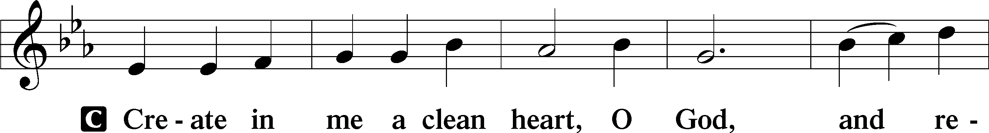
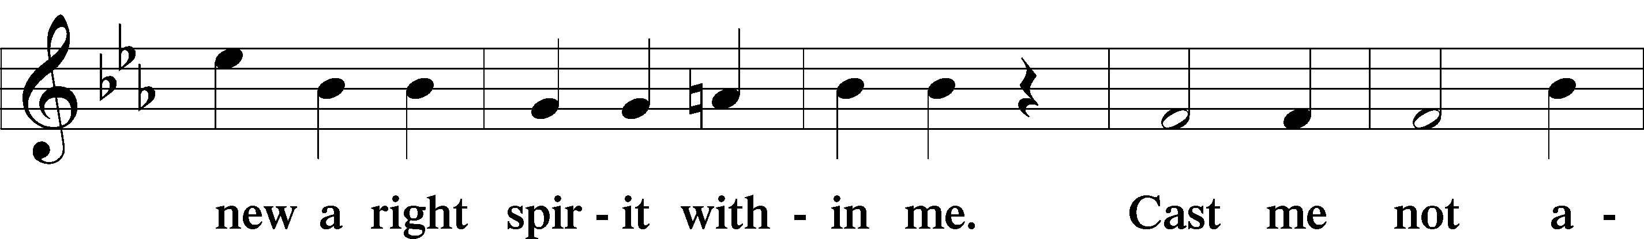
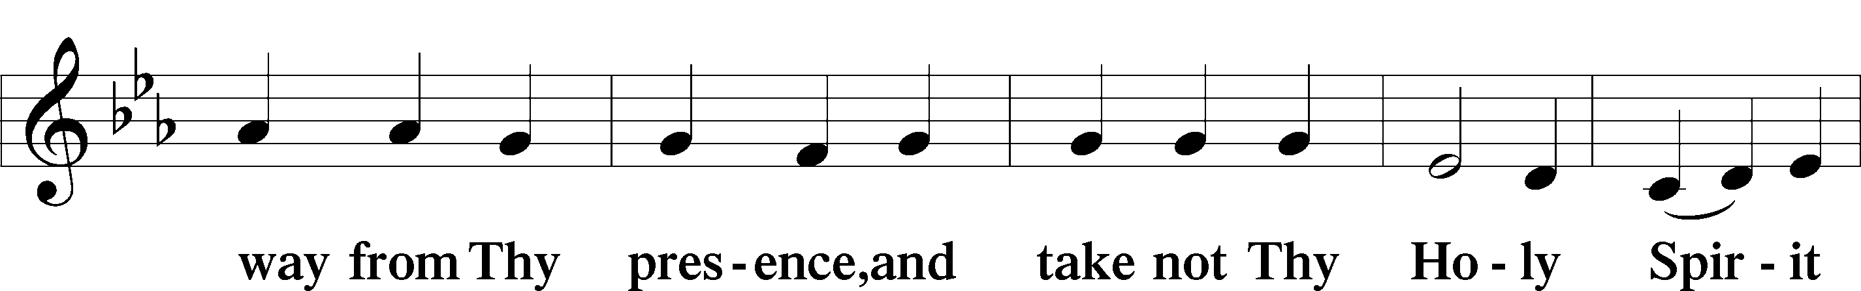
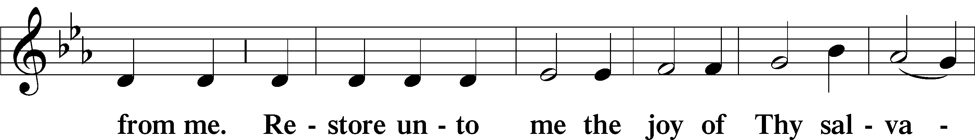
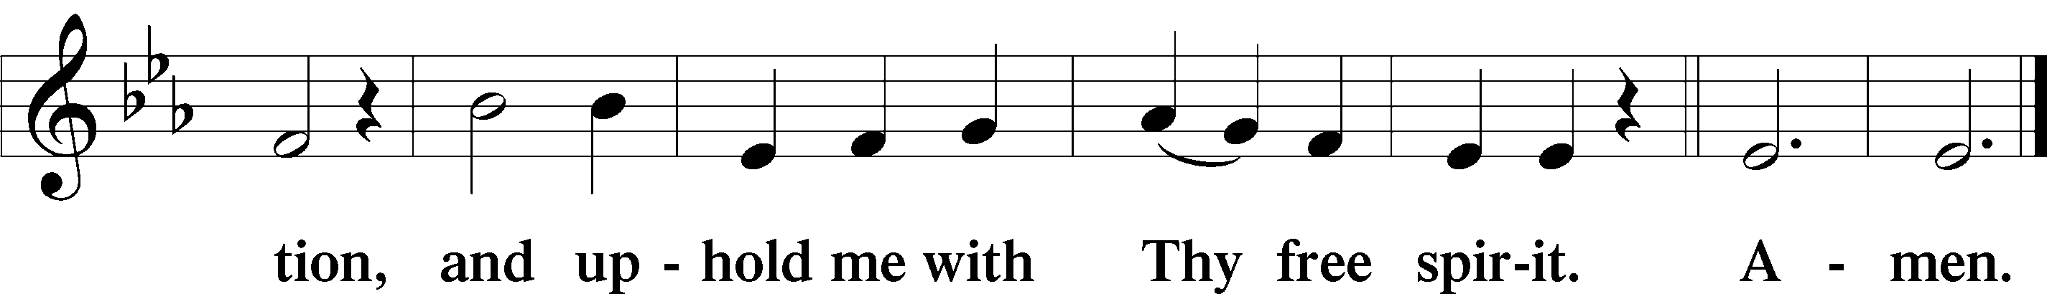

Prayer of the Church “Hear Our Prayer“

Preface LSB 194
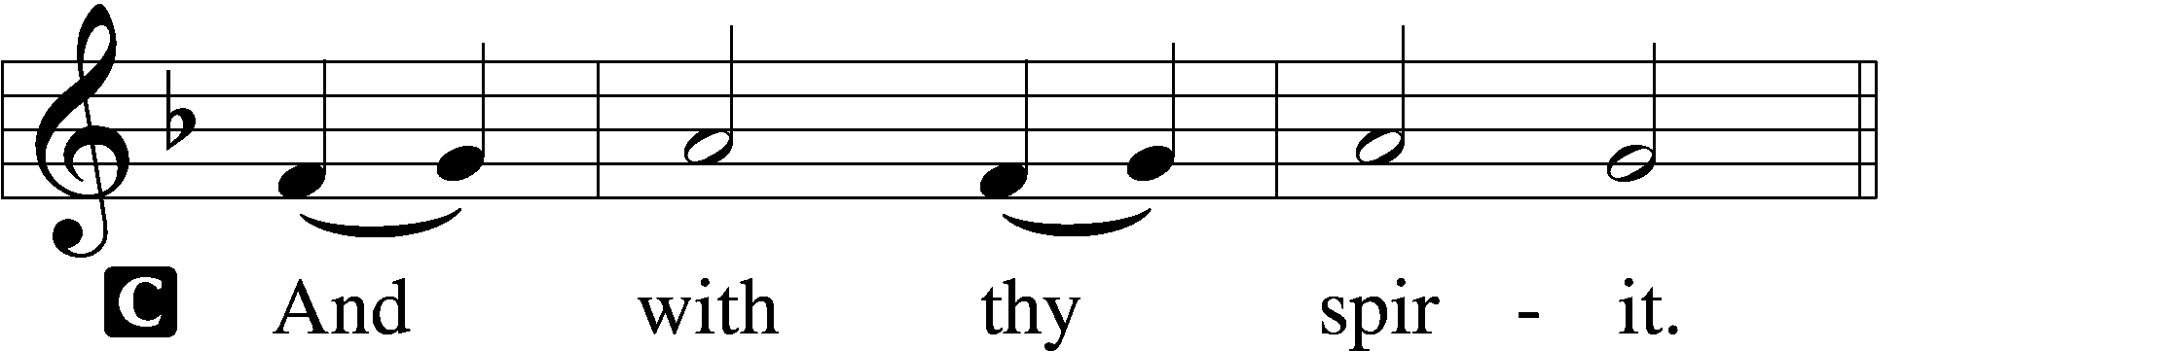

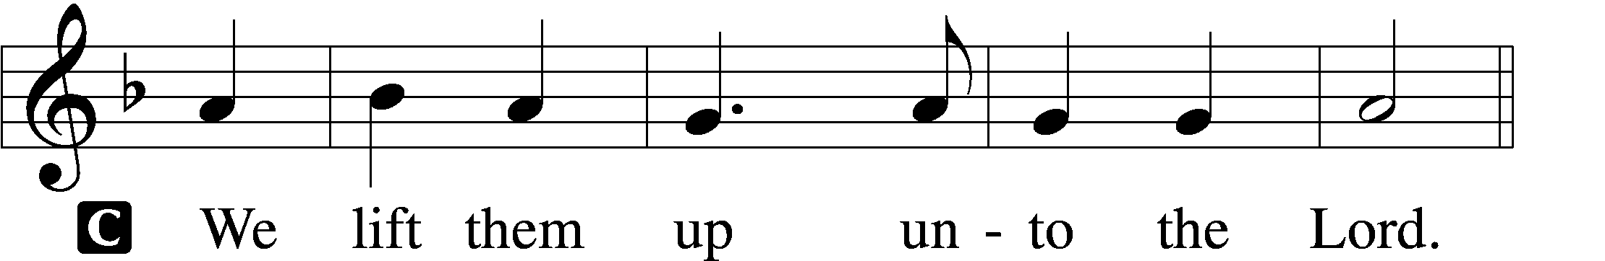

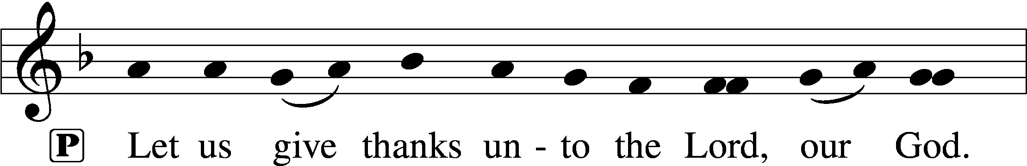
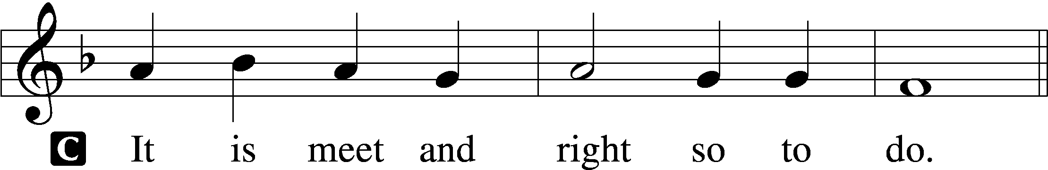

Sanctus LSB 195
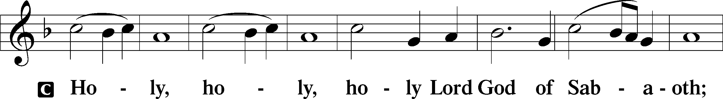
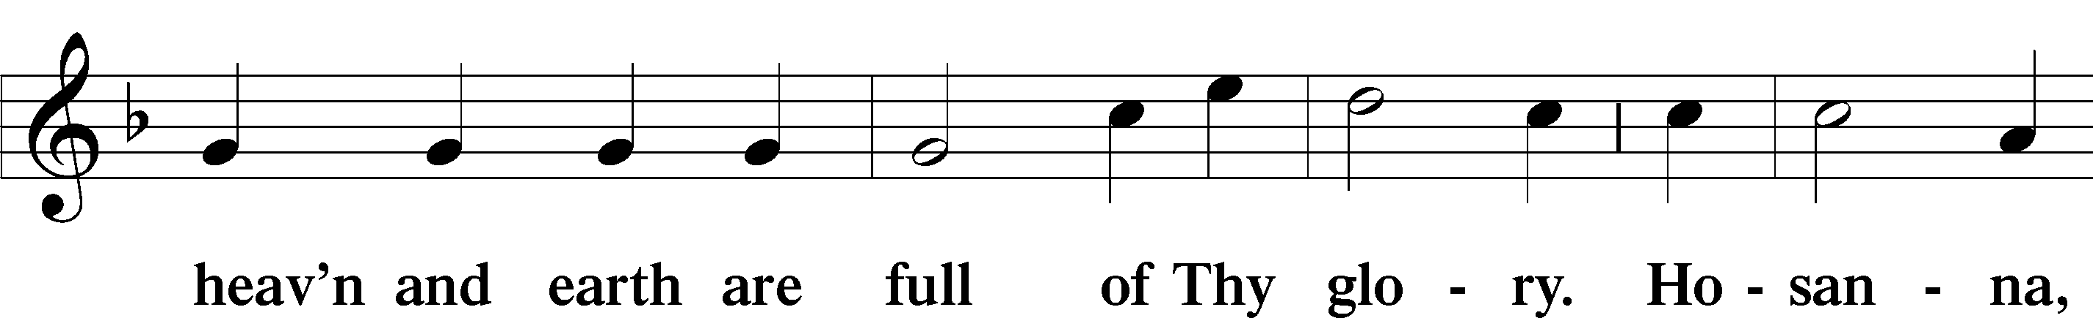
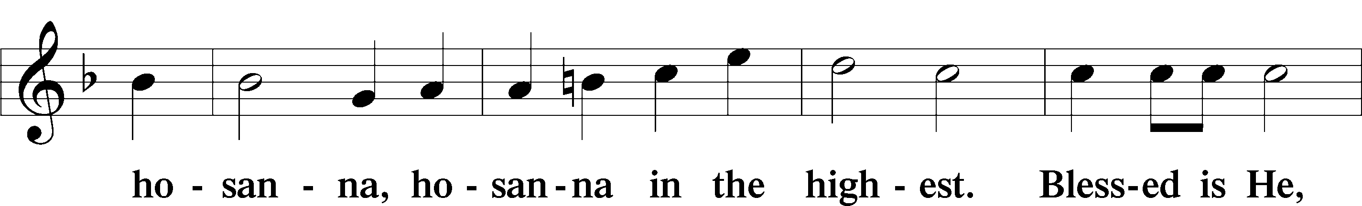
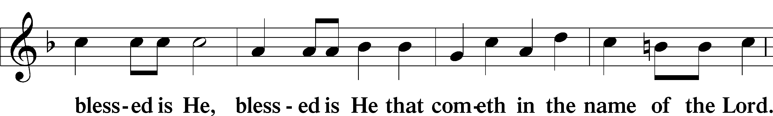
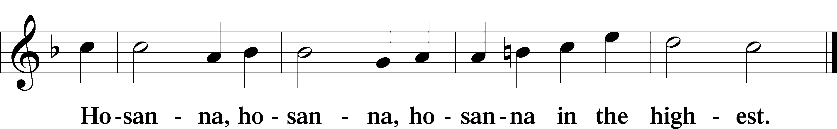

Lord’s Prayer LSB 196
The Words of Our Lord LSB 197

Pax Domini LSB 197
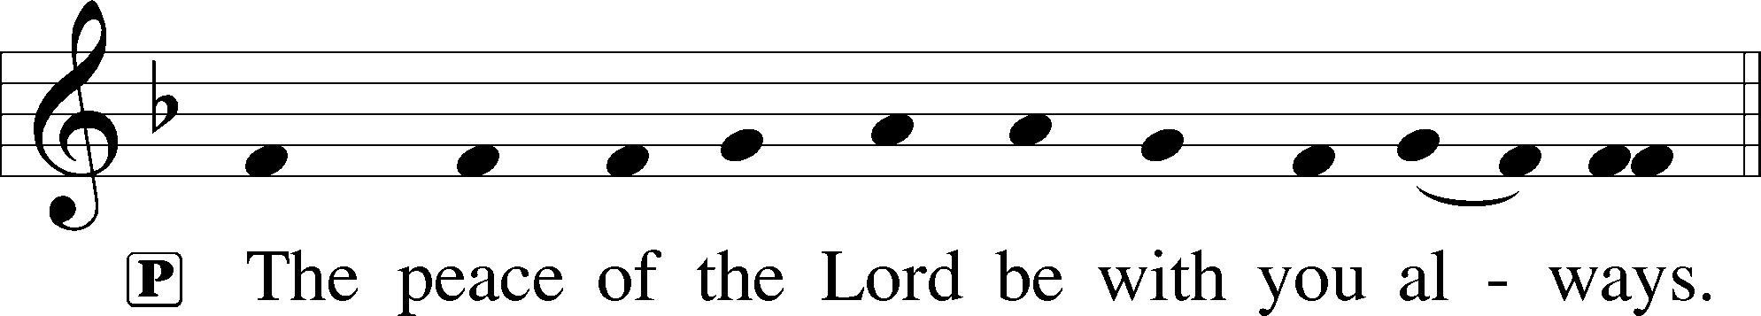

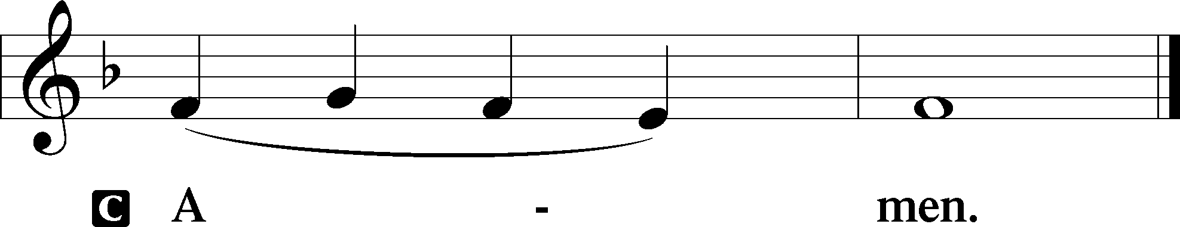

Agnus Dei LSB 198
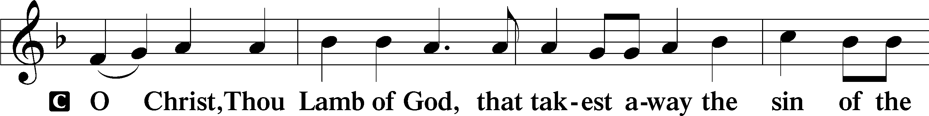
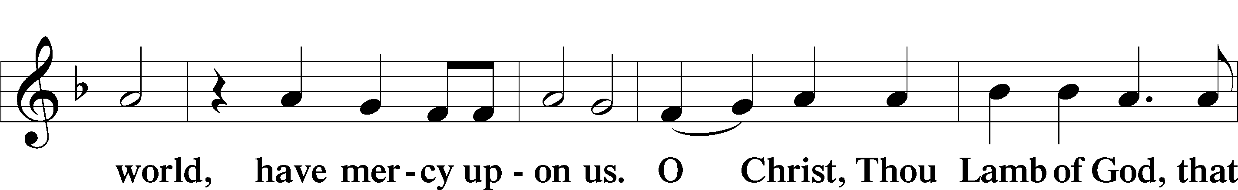
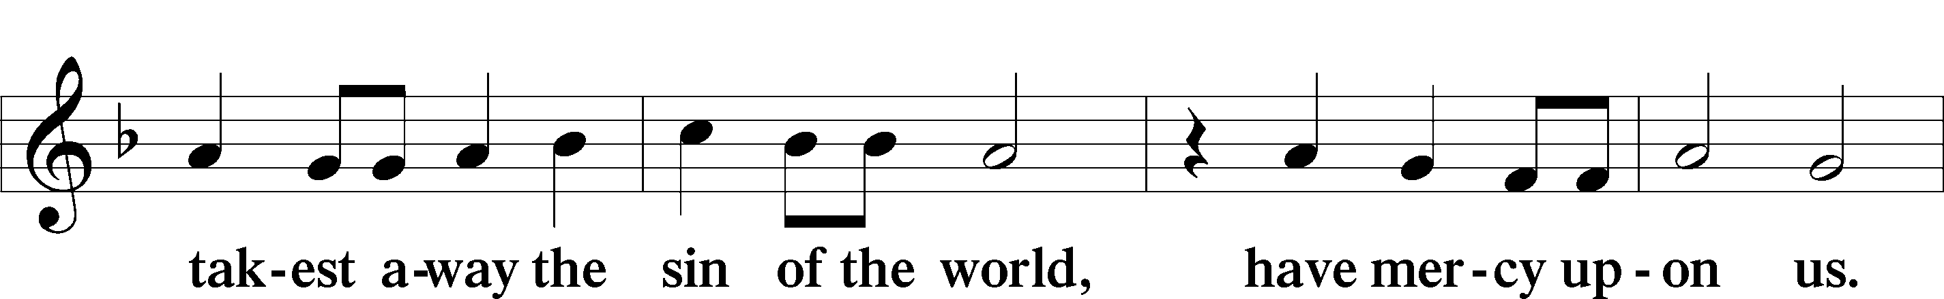
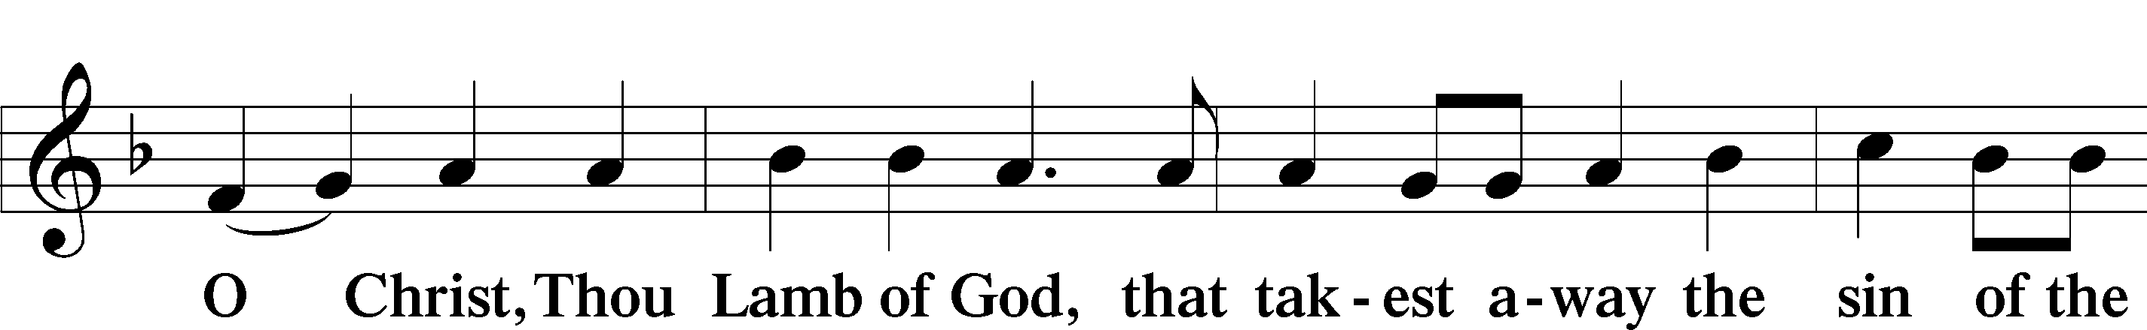
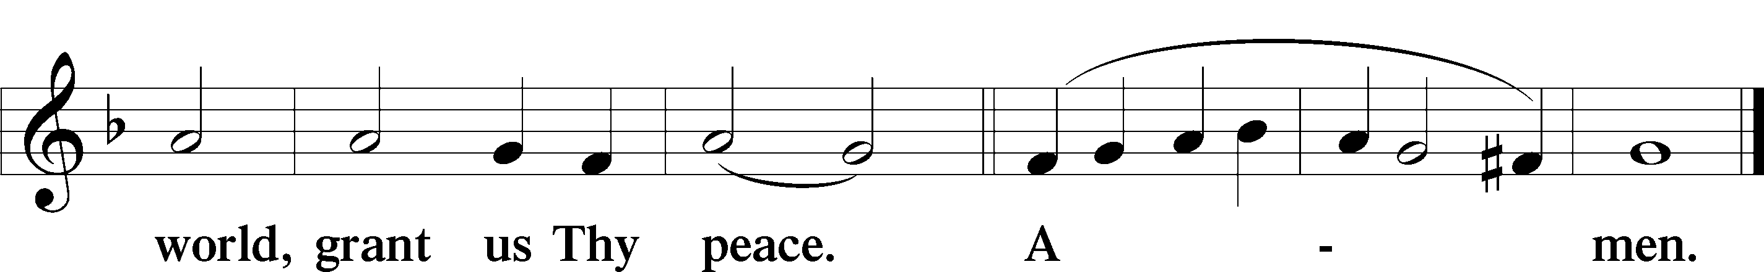

392 God Loves Me Dearly
1 God loves me dearly,
Grants me salvation,
God loves me dearly,
Loves even me. Refrain

ref Therefore I’ll say again:
God loves me dearly,
God loves me dearly,
Loves even me.

2 I was in slav’ry,
Sin, death, and darkness;
God’s love was working
To make me free. Refrain

3 He sent forth Jesus,
My dear Redeemer,
He sent forth Jesus
And set me free. Refrain

4 Jesus, my Savior,
Himself did offer;
Jesus, my Savior,
Paid all I owed. Refrain

5 Now I will praise You,
O Love Eternal;
Now I will praise You
All my life long. Refrain
Text: August Rische, 1819–1906; tr. composite
Text: Public domain

555 Salvation unto Us Has Come
1 Salvation unto us has come
By God’s free grace and favor;
Good works cannot avert our doom,
They help and save us never.
Faith looks to Jesus Christ alone,
Who did for all the world atone;
He is our one Redeemer.

2 What God did in His Law demand
And none to Him could render
Caused wrath and woe on ev’ry hand
For man, the vile offender.
Our flesh has not those pure desires
The spirit of the Law requires,
And lost is our condition.

3 It was a false, misleading dream
That God His Law had given
That sinners could themselves redeem
And by their works gain heaven.
The Law is but a mirror bright
To bring the inbred sin to light
That lurks within our nature.

4 From sin our flesh could not abstain,
Sin held its sway unceasing;
The task was useless and in vain,
Our guilt was e’er increasing.
None can remove sin’s poisoned dart
Or purify our guileful heart—
So deep is our corruption.

5 Yet as the Law must be fulfilled
Or we must die despairing,
Christ came and has God’s anger stilled,
Our human nature sharing.
He has for us the Law obeyed
And thus the Father’s vengeance stayed
Which over us impended.

6 Since Christ has full atonement made
And brought to us salvation,
Each Christian therefore may be glad
And build on this foundation.
Your grace alone, dear Lord, I plead,
Your death is now my life indeed,
For You have paid my ransom.

7 Let me not doubt, but truly see
Your Word cannot be broken;
Your call rings out, “Come unto Me!”
No falsehood have You spoken.
Baptized into Your precious name,
My faith cannot be put to shame,
And I shall never perish.

8 The Law reveals the guilt of sin
And makes us conscience-stricken;
But then the Gospel enters in
The sinful soul to quicken.
Come to the cross, trust Christ, and live;
The Law no peace can ever give,
No comfort and no blessing.

9 Faith clings to Jesus’ cross alone
And rests in Him unceasing;
And by its fruits true faith is known,
With love and hope increasing.
For faith alone can justify;
Works serve our neighbor and supply
The proof that faith is living.

D 10 All blessing, honor, thanks, and praise
To Father, Son, and Spirit,
The God who saved us by His grace;
All glory to His merit.
O triune God in heav’n above,
You have revealed Your saving love;
Your blessèd name we hallow.
Text: Paul Speratus, 1484–1551; tr. The Lutheran Hymnal, 1941, alt.
Text: Public domain

744 Amazing Grace sts. 1–5
1 Amazing grace—how sweet the sound—
That saved a wretch like me!
I once was lost but now am found,
Was blind but now I see!

2 The Lord has promised good to me,
His Word my hope secures;
He will my shield and portion be
As long as life endures.

3 Through many dangers, toils, and snares
I have already come;
His grace has brought me safe thus far,
His grace will lead me home.

4 Yes, when this flesh and heart shall fail
And mortal life shall cease,
Amazing grace shall then prevail
In heaven’s joy and peace.

5 When we’ve been there ten thousand years,
Bright shining as the sun,
We’ve no less days to sing God’s praise
Than when we’d first begun.
Text (sts. 1–4): John Newton, 1725–1807, alt.; (st. 5): A Collection of Sacred Ballads, 1790, Richmond
Text: Public domain

Nunc Dimittis LSB 199
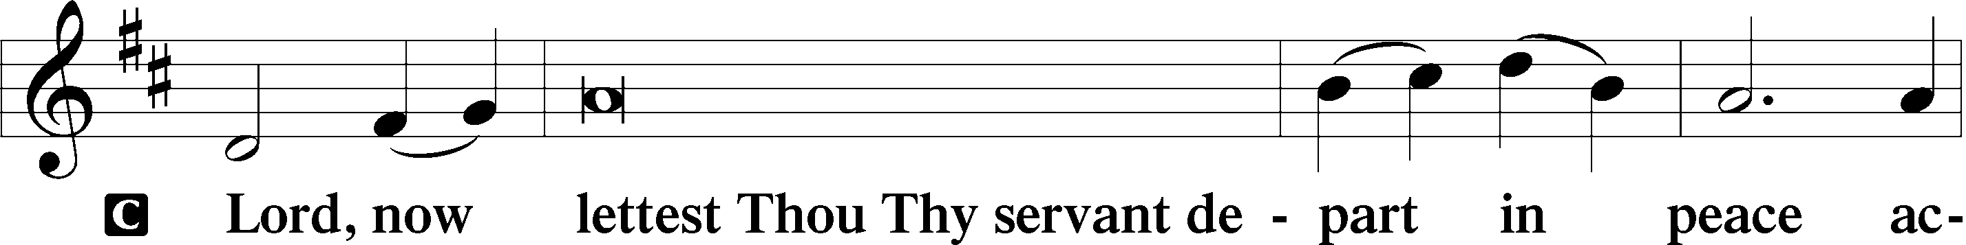
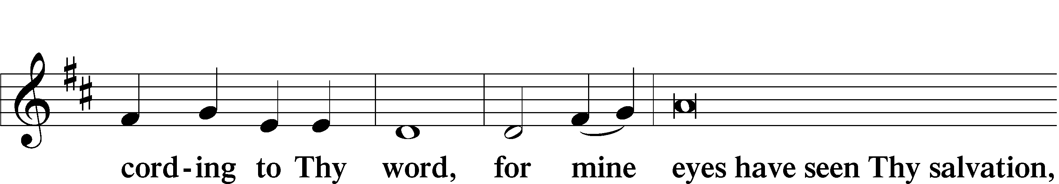
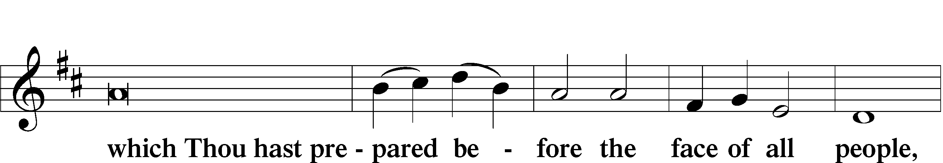
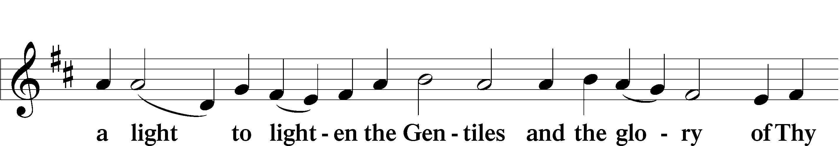
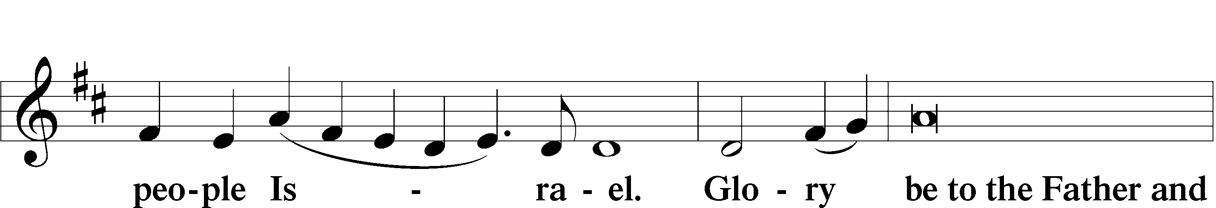
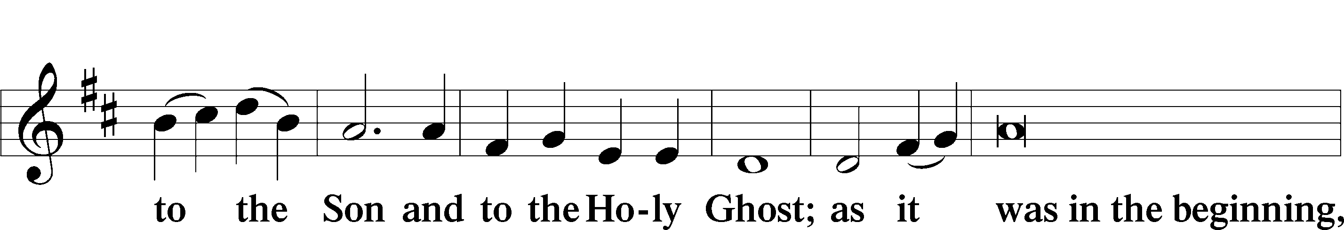
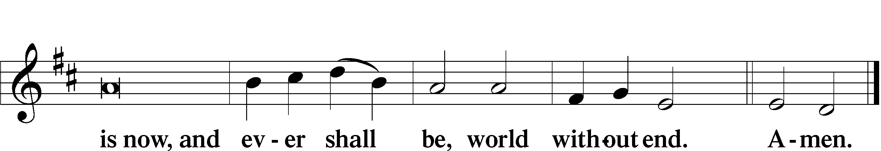

Thanksgiving LSB 200
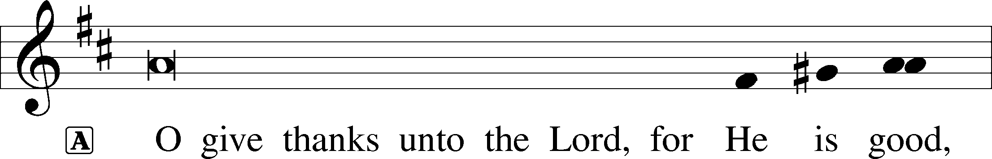

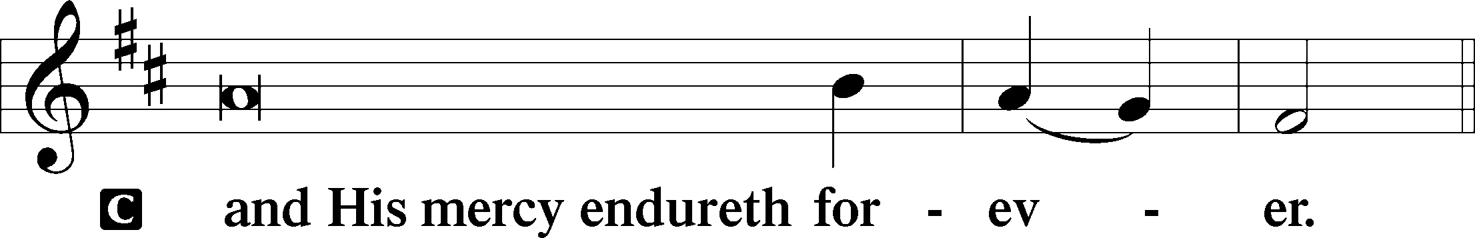

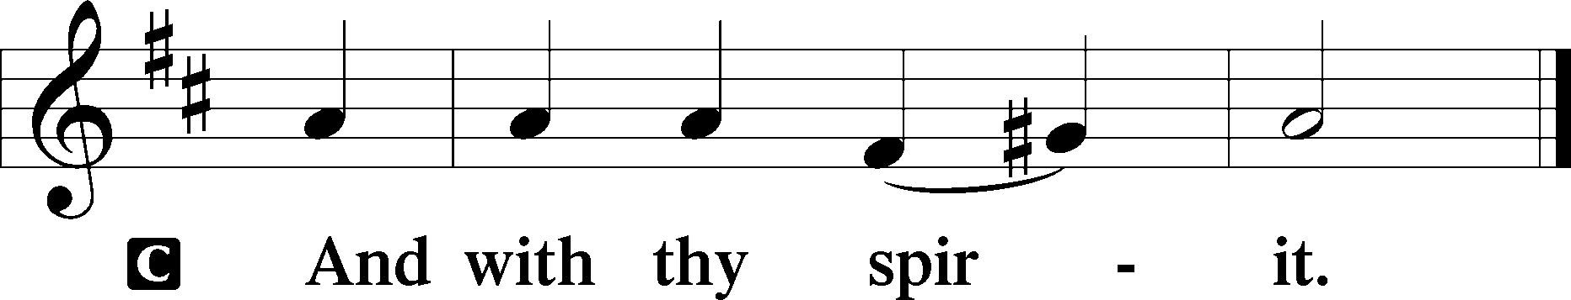
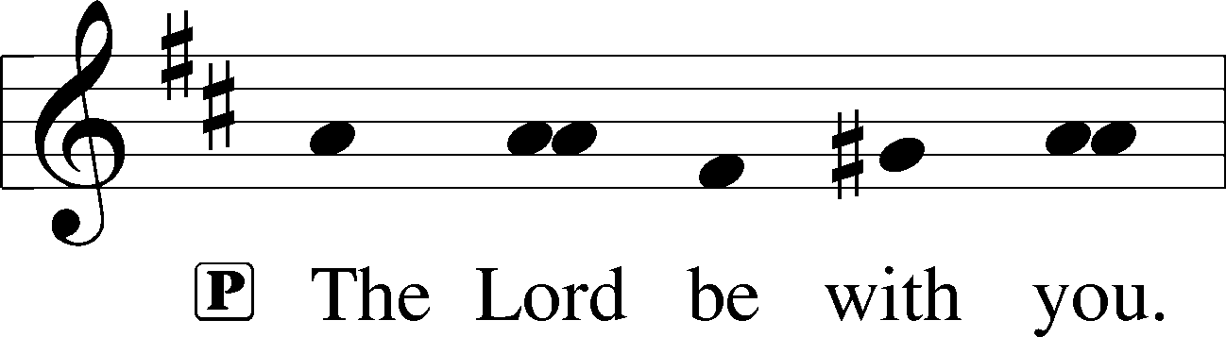

Benedicamus & Benediction

578 Thy Strong Word
1 Thy strong word did cleave the darkness;
At Thy speaking it was done.
For created light we thank Thee,
While Thine ordered seasons run.
Alleluia, alleluia!
Praise to Thee who light dost send!
Alleluia, alleluia!
Alleluia without end!

2 Lo, on those who dwelt in darkness,
Dark as night and deep as death,
Broke the light of Thy salvation,
Breathed Thine own life-breathing breath.
Alleluia, alleluia!
Praise to Thee who light dost send!
Alleluia, alleluia!
Alleluia without end!

3 Thy strong Word bespeaks us righteous;
Bright with Thine own holiness,
Glorious now, we press toward glory,
And our lives our hopes confess.
Alleluia, alleluia!
Praise to Thee who light dost send!
Alleluia, alleluia!
Alleluia without end!

4 From the cross Thy wisdom shining
Breaketh forth in conqu’ring might;
From the cross forever beameth
All Thy bright redeeming light.
Alleluia, alleluia!
Praise to Thee who light dost send!
Alleluia, alleluia!
Alleluia without end!

5 Give us lips to sing Thy glory,
Tongues Thy mercy to proclaim,
Throats that shout the hope that fills us,
Mouths to speak Thy holy name.
Alleluia, alleluia!
May the light which Thou dost send
Fill our songs with alleluias,
Alleluias without end!

D 6 God the Father, light-creator,
To Thee laud and honor be.
To Thee, Light of Light begotten,
Praise be sung eternally.
Holy Spirit, light-revealer,
Glory, glory be to Thee.
Mortals, angels, now and ever
Praise the holy Trinity!
Text: Martin H. Franzmann, 1907–76
Text: © 1969 Concordia Publishing House. Used by permission: LSB Hymn License no. 110004822

