Fourteenth Sunday after Trinity

Sunday, September 18, 2022
Divine Service 5, Page 213
LARGE PRINT

Divine Shepherd Lutheran Church & School

7308 Wedgewood Drive
Black Hawk, SD 57718
“We are baptized children of God, forgiven and redeemed by Jesus. We are His family, called together to receive His gifts and serve others.”
Pastor Randy Sturzenbecher
Vicar Dennis Mercer
Office 787-6438, Cell 391-0428, ECC 791-1131
Email: DSLCPastor@divineshep.org
DSLCSecretary@divineshep.org

Greetings to all in the Name of the Risen Lord!
May our worship celebrate the joy and hope, peace and presence, of our Lord Jesus Christ, raised to life for us. We welcome all, especially our guests. If you do not have a church home, please consider Divine Shepherd. We would love to have you as part of our family. Please take a minute and sign our guest book.

A prayer before Worship
This is the day you have made, O Lord Jesus, a day of new life and eternal celebration! The stone is moved; death is defeated; heaven is open. As Your disciples first saw and believed Your victory over the tomb, so give us joy in the promise You made and keep for us: because You live, we live also! Amen.

The Lord’s Supper
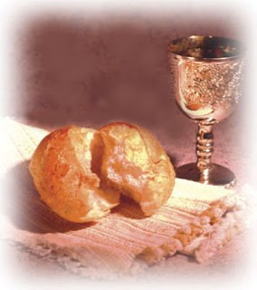
The Lord’s Supper is celebrated in the confession and gladness that, as our Lord says, He gives into our mouth not only bread and wine but His very body and blood to eat and drink for the forgiveness of sins and to strengthen our union with Him and with one another. Our Lord Jesus invites to His table those who trust His Words, repent of all sin, and set aside any refusal to forgive and love as He forgives and loves us, that they may show forth His death until He comes.

Whoever, therefore, eats the bread or drinks the blood of the Lord in an unworthy manner will be guilty concerning the body and blood of the Lord.
(1 Cor 11:28 ESV) Holy Communion is a confession of the faith which is confessed at this altar. Any who holds a confession differing from that of the Holy Scriptures, or are not a member in good standing with the LC-MS, are asked to speak with Pastor Sturzenbecher.

849 Praise the One Who Breaks the Darkness
1 Praise the One who breaks the darkness
With a liberating light;
Praise the One who frees the pris’ners,
Turning blindness into sight.
Praise the One who preached the Gospel,
Healing ev’ry dread disease,
Calming storms, and feeding thousands
With the very Bread of peace.
2 Praise the One who blessed the children
With a strong, yet gentle, word;
Praise the One who drove out demons
With the piercing, two-edged sword.
Praise the One who brings cool water
To the desert’s burning sand;
From this Well comes living water,
Quenching thirst in ev’ry land.
3 Let us praise the Word Incarnate,
Christ, who suffered in our place.
Jesus died and rose victorious
That we may know God by grace.
Let us sing for joy and gladness,
Seeing what our God has done;
Let us praise the true Redeemer,
Praise the One who makes us one.
Text: Rusty Edwards, 1955
Text: © 1987 Hope Publishing Co. Used by permission: LSB Hymn License no. 110004822
Invocation & Exhortation
P Beloved in the Lord! Let us draw near with a true heart and confess our sins unto God our Father, beseeching Him in the name of our Lord Jesus Christ to grant us forgiveness.
P Our help is in the name of the Lord,
C who made heaven and earth.
P I said, I will confess my transgressions unto the Lord,
C and You forgave the iniquity of my sin.

Confession & Absolution
P O almighty God, merciful Father,
C I, a poor, miserable sinner, confess unto You all my sins and iniquities with which I have ever offended You and justly deserved Your temporal and eternal punishment. But I am heartily sorry for them and sincerely repent of them, and I pray You of Your boundless mercy and for the sake of the holy, innocent, bitter sufferings and death of Your beloved Son, Jesus Christ, to be gracious and merciful to me, a poor, sinful being.

P Upon this your confession, I, by virtue of my office, as a called and ordained servant of the Word, announce the grace of God unto all of you, and in the stead and by the command of my Lord Jesus Christ I forgive you all your sins in the name of the Father and of the + Son and of the Holy Spirit.

Introit
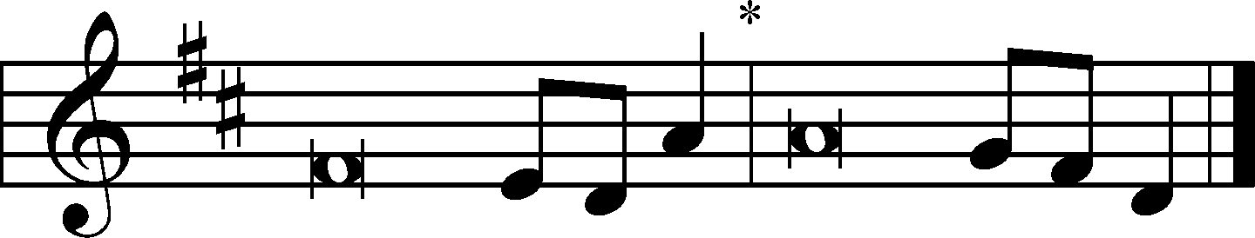
Psalm 84:1–2a, 4, 10b, 11b; antiphon: vv. 9–10a
Behold our shield, | O God;*
look on the face of your a- | nointed!
For a day | in your courts*
is better than a thousand | elsewhere.
How lovely is your dwelling place, O | Lord of hosts!*
My soul longs, yes, faints for the courts | of the Lord.
Blessèd are those who dwell | in your house,*
ever sing- | ing your praise!
I would rather be a doorkeeper in the house | of my God*
than dwell in the tents of | wickedness.
The Lord bestows favor and | honor.*
No good thing does he withhold from those who walk up- | rightly.
Glory be to the Father and | to the Son*
and to the Holy | Spirit;
as it was in the be- | ginning,*
is now, and will be forever. | Amen.
Behold our shield, | O God;*
look on the face of your a- | nointed!
For a day | in your courts*
is better than a thousand | elsewhere.

Kyrie ♪ LSB 617 vs 1
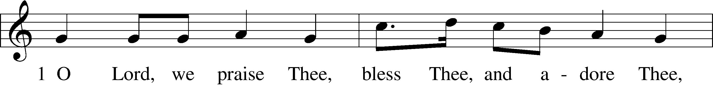
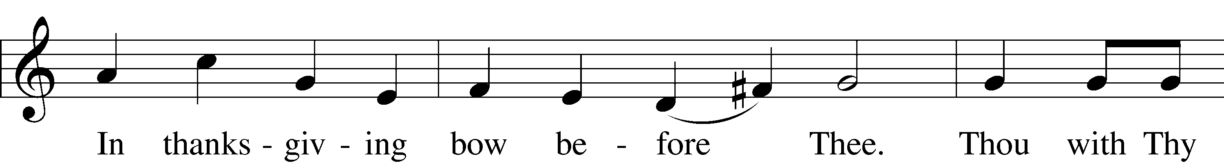
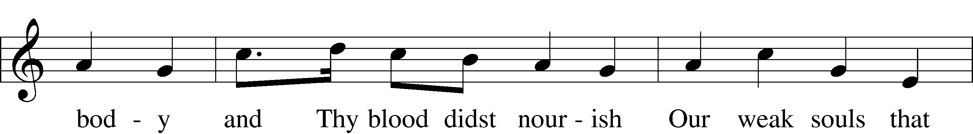
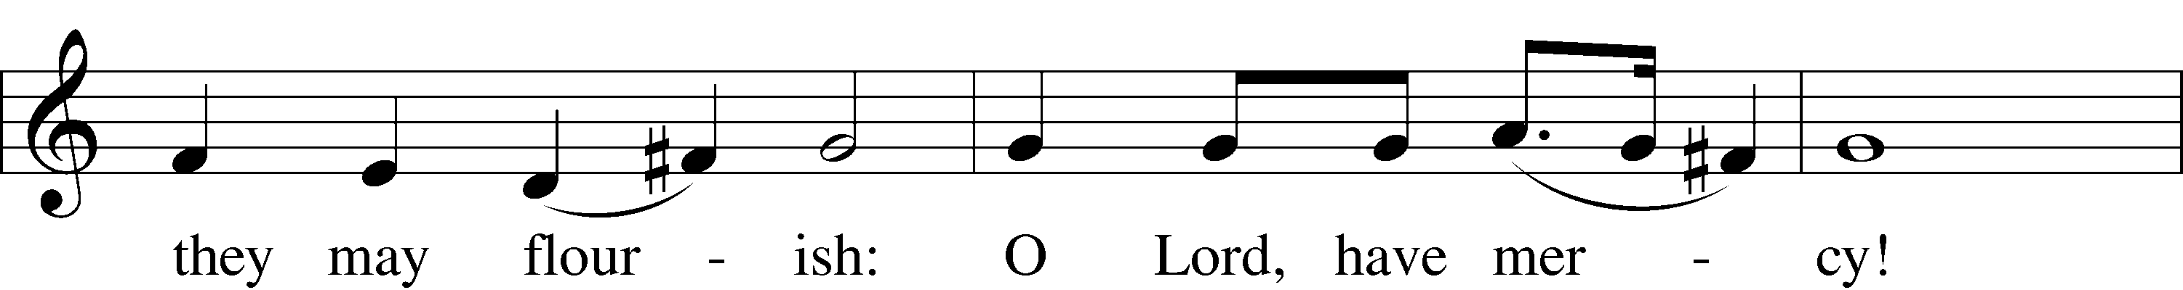
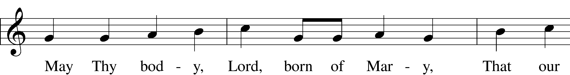
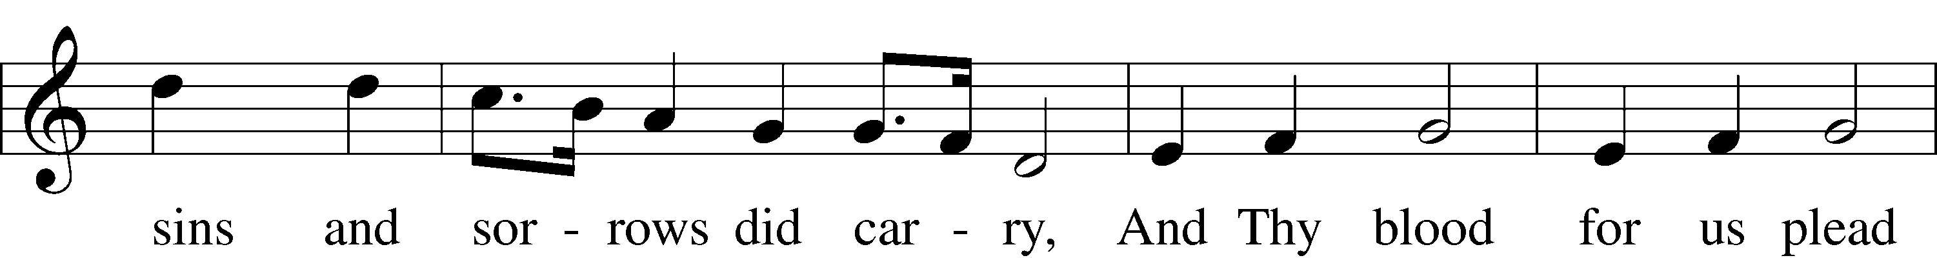
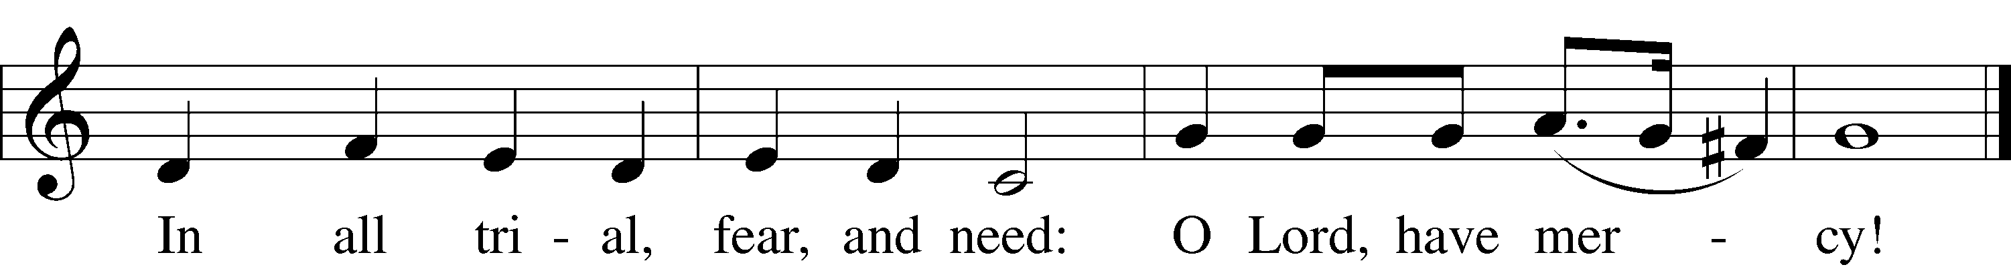

Gloria In Excelsis LSB 822 vs 4
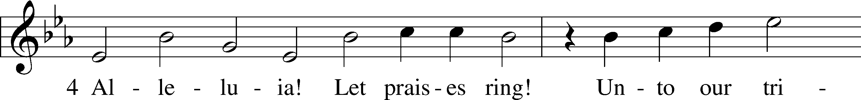
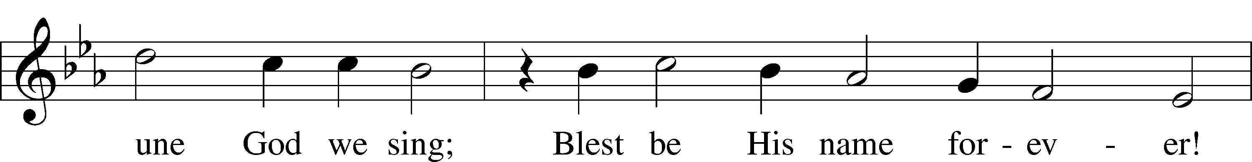
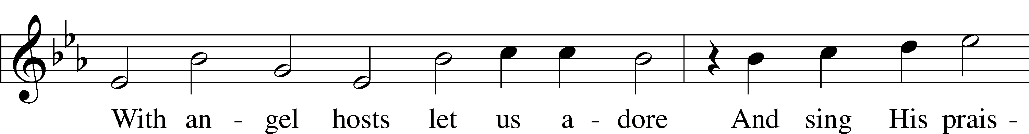
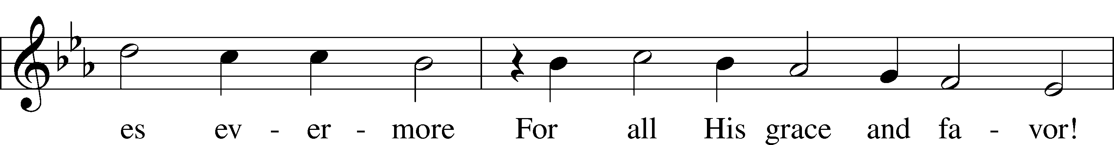
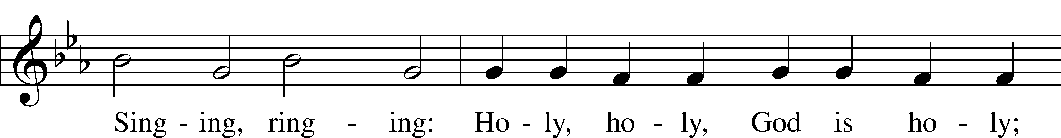
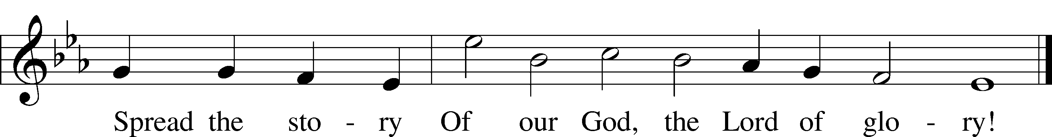

Salutation and Collect of the Day
P The Lord be with you.
C And also with you.

P Let us pray.
C Amen.

OLD TESTAMENT READING Proverbs 4:10–23
¹⁰Hear, my son, and accept my words,
that the years of your life may be many.
¹¹I have taught you the way of wisdom;
I have led you in the paths of uprightness.
¹²When you walk, your step will not be hampered,
and if you run, you will not stumble.
¹³Keep hold of instruction; do not let go;
guard her, for she is your life.
¹⁴Do not enter the path of the wicked,
and do not walk in the way of the evil.
¹⁵Avoid it; do not go on it;
turn away from it and pass on.
¹⁶For they cannot sleep unless they have done wrong;
they are robbed of sleep unless they have made someone stumble.
¹⁷For they eat the bread of wickedness
and drink the wine of violence.
¹⁸But the path of the righteous is like the light of dawn,
which shines brighter and brighter until full day.
¹⁹The way of the wicked is like deep darkness;
they do not know over what they stumble.
²⁰My son, be attentive to my words;
incline your ear to my sayings.
²¹Let them not escape from your sight;
keep them within your heart.
²²For they are life to those who find them,
and healing to all their flesh.
²³Keep your heart with all vigilance,
for from it flow the springs of life.
Catechetical Review
THE SIXTH COMMANDMENT
You shall not commit adultery.

What does this mean?
We should fear and love God so that we lead a sexually pure and decent life in what we say and do, and husband and wife love and honor each other.

THE SIXTH PETITION
And lead us not into temptation.
Lead us not into temptation.

What does this mean?
God tempts no one. We pray in this petition that God would guard and keep us so that the devil, the world, and our sinful nature may not deceive us or mislead us into false belief, despair, and other great shame and vice. Although we are attacked by these things, we pray that we may finally overcome them and win the victory.

EPISTLE Galatians 5:16–24
¹⁶But I say, walk by the Spirit, and you will not gratify the desires of the flesh. ¹⁷For the desires of the flesh are against the Spirit, and the desires of the Spirit are against the flesh, for these are opposed to each other, to keep you from doing the things you want to do. ¹⁸But if you are led by the Spirit, you are not under the law. ¹⁹Now the works of the flesh are evident: sexual immorality, impurity, sensuality, ²⁰idolatry, sorcery, enmity, strife, jealousy, fits of anger, rivalries, dissensions, divisions, ²¹envy, drunkenness, orgies, and things like these. I warn you, as I warned you before, that those who do such things will not inherit the kingdom of God. ²²But the fruit of the Spirit is love, joy, peace, patience, kindness, goodness, faithfulness, ²³gentleness, self-control; against such things there is no law. ²⁴And those who belong to Christ Jesus have crucified the flesh with its passions and desires.

528 OH, FOR A THOUSAND TONGUES TO SING
1 Oh, for a thousand tongues to sing
My great Redeemer’s praise,
The glories of my God and King,
The triumphs of His grace!

2 My gracious Master and my God,
Assist me to proclaim,
To spread through all the earth abroad,
The honors of Thy name.

3 Jesus! The name that charms our fears,
That bids our sorrows cease;
’Tis music in the sinner’s ears,
’Tis life and health and peace.

4 He breaks the pow’r of canceled sin;
He sets the pris’ner free.
His blood can make the foulest clean;
His blood avails for me.

5 Look unto Him, ye nations; own
Your God, ye fallen race.
Look and be saved through faith alone,
Be justified by grace.

6 See all your sins on Jesus laid;
The Lamb of God was slain.
His soul was once an off’ring made
For ev’ry soul of man.

7 To God all glory, praise, and love
Be now and ever giv’n
By saints below and saints above,
The Church in earth and heav’n.
Text: Charles Wesley, 1707–88, alt.
Text: Public domain
HOLY GOSPEL Luke 17:11–19
¹¹On the way to Jerusalem [Jesus] was passing along between Samaria and Galilee. ¹²And as he entered a village, he was met by ten lepers, who stood at a distance ¹³and lifted up their voices, saying, “Jesus, Master, have mercy on us.” ¹⁴When he saw them he said to them, “Go and show yourselves to the priests.” And as they went they were cleansed. ¹⁵Then one of them, when he saw that he was healed, turned back, praising God with a loud voice; ¹⁶and he fell on his face at Jesus’ feet, giving him thanks. Now he was a Samaritan. ¹⁷Then Jesus answered, “Were not ten cleansed? Where are the nine? ¹⁸Was no one found to return and give praise to God except this foreigner?” ¹⁹And he said to him, “Rise and go your way; your faith has made you well.”

APOSTLES’ CREED
C I believe in God, the Father Almighty,
maker of heaven and earth.

And in Jesus Christ, His only Son, our Lord,
who was conceived by the Holy Spirit,
born of the virgin Mary,
suffered under Pontius Pilate,
was crucified, died and was buried.
He descended into hell.
The third day He rose again from the dead.
He ascended into heaven
and sits at the right hand of God the Father Almighty.
From thence He will come to judge the living and the dead.

I believe in the Holy Spirit,
the holy Christian Church,
the communion of saints,
the forgiveness of sins,
the resurrection of the body,
and the life T everlasting. Amen.

Sermon
Prayer of the Church “Hear Our Prayer“
Offering

Preface
P The Lord be with you.
C And also with you.
P Lift up your hearts.
C We lift them to the Lord.
P Let us give thanks to the Lord our God.
C It is right to give Him thanks and praise.
P It is truly good, right, and salutary that we should at all times and in all places give thanks to You, O Lord our God, king of all creation, for You have had mercy on us and given Your only-begotten Son that whoever believes in Him should not perish but have eternal life. Grant us Your Spirit, gracious Father, that we may give heed to the testament of Your Son in true faith and, above all, firmly take to heart the words with which Christ gives to us His body and blood for our forgiveness. By Your grace, lead us to remember and give thanks for the boundless love which He manifested to us when, by pouring out His precious blood, He saved us from Your righteous wrath and from sin, death, and hell. Grant that we may receive the bread and wine, that is, His body and blood, as a gift, guarantee, and pledge of His salvation. Graciously receive our prayers; deliver and preserve us. To You alone, O Father, be all glory, honor, and worship, with the Son and the Holy Spirit, one God, now and forever.
C Amen.

Lord’s Prayer

The Words of Our Lord LSB 217
P Our Lord Jesus Christ, on the night when He was betrayed, took bread, and when He had given thanks, He broke it and gave it to the disciples and said: “Take, eat; this is My + body, which is given for you. This do in remembrance of Me.”
In the same way also He took the cup after supper, and when He had given thanks, He gave it to them, saying: “Drink of it, all of you; this cup is the new testament in My + blood, which is shed for you for the forgiveness of sins. This do, as often as you drink it, in remembrance of Me.”

Sanctus LSB 507 vs 1&3
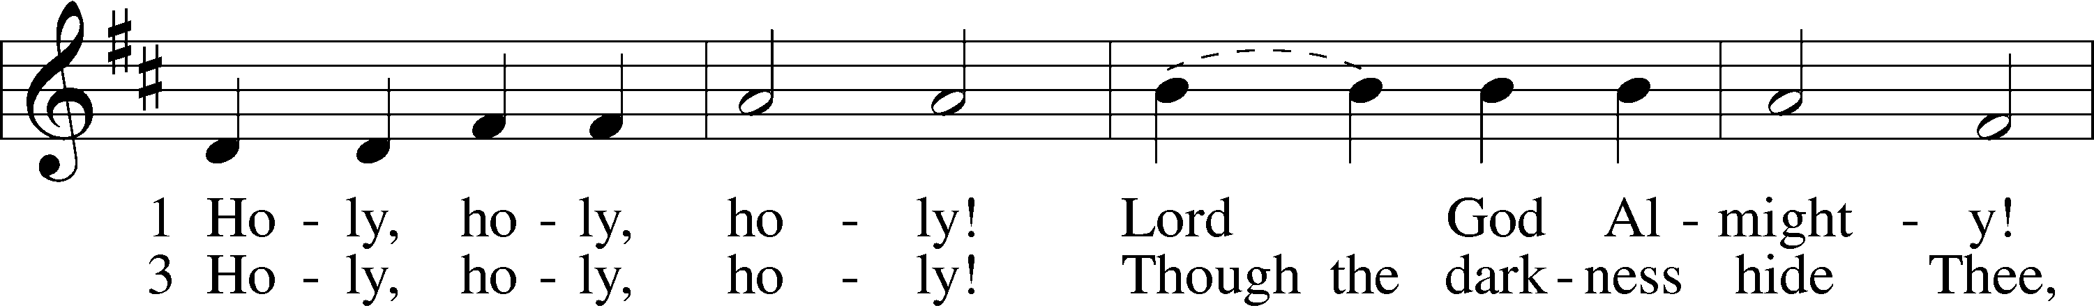
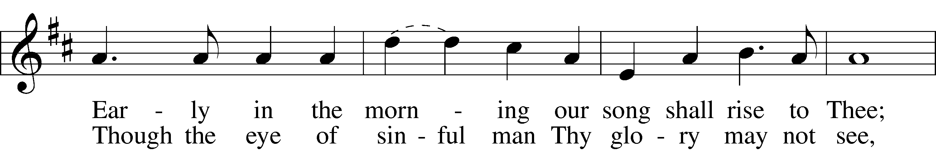
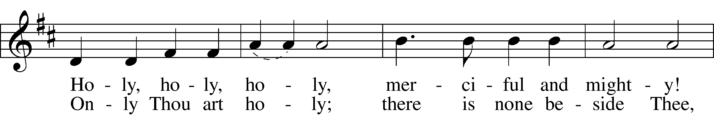
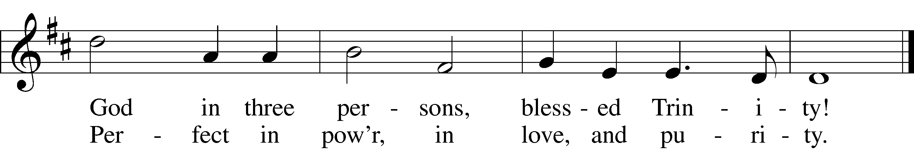

Pax Domini
P The peace of the Lord be with you always.
C Amen.

AGNUS DEI LSB 198
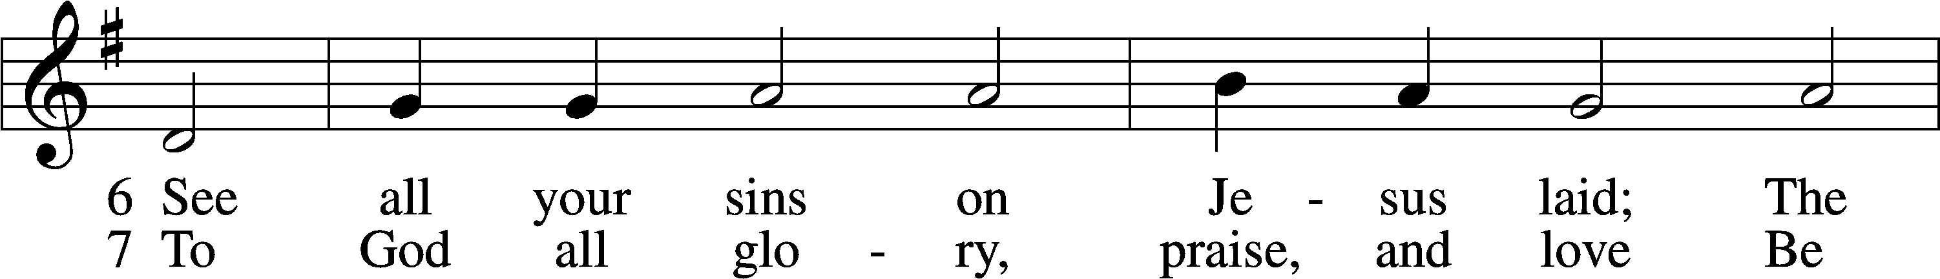
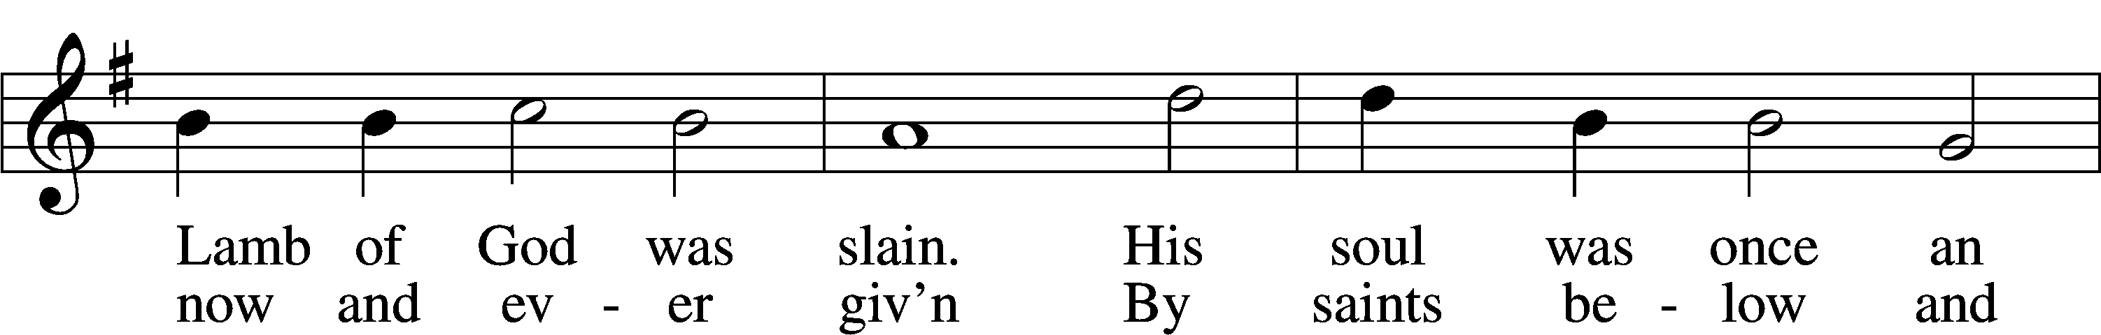
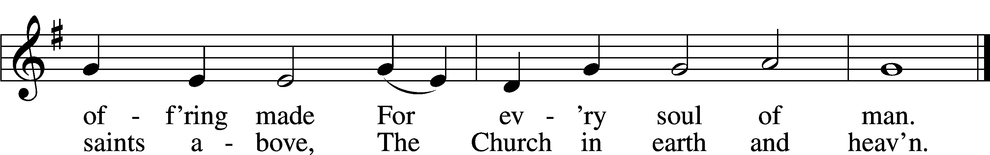

710 The Lord’s My Shepherd, I’ll Not Want
1 The Lord’s my shepherd, I’ll not want;
He makes me down to lie
In pastures green; He leadeth me
The quiet waters by.

2 My soul He doth restore again
And me to walk doth make
Within the paths of righteousness,
E’en for His own name’s sake.

3 Yea, though I walk in death’s dark vale,
Yet will I fear no ill;
For Thou art with me, and Thy rod
And staff me comfort still.

4 My table Thou hast furnishèd
In presence of my foes;
My head Thou dost with oil anoint,
And my cup overflows.

5 Goodness and mercy all my life
Shall surely follow me;
And in God’s house forevermore
My dwelling place shall be.
Text: The Psalms of David in Meeter, 1650, Edinburgh
Text: Public domain

636 Soul, Adorn Yourself with Gladness
1 Soul, adorn yourself with gladness,
Leave the gloomy haunts of sadness,
Come into the daylight’s splendor,
There with joy your praises render.
Bless the One whose grace unbounded
This amazing banquet founded;
He, though heav’nly, high, and holy,
Deigns to dwell with you most lowly.

2 Hasten as a bride to meet Him,
And with loving rev’rence greet Him.
For with words of life immortal
He is knocking at your portal.
Open wide the gates before Him,
Saying, as you there adore Him:
Grant, Lord, that I now receive You,
That I nevermore will leave You.

3 He who craves a precious treasure
Neither cost nor pain will measure;
But the priceless gifts of heaven
God to us has freely given.
Though the wealth of earth were proffered,
None could buy the gifts here offered:
Christ’s true body, for you riven,
And His blood, for you once given.

4 Now in faith I humbly ponder
Over this surpassing wonder
That the bread of life is boundless
Though the souls it feeds are countless:
With the choicest wine of heaven
Christ’s own blood to us is given.
Oh, most glorious consolation,
Pledge and seal of my salvation!

5 Jesus, source of lasting pleasure,
Truest friend, and dearest treasure,
Peace beyond all understanding,
Joy into all life expanding:
Humbly now, I bow before You;
Love incarnate, I adore You;
Worthily let me receive You
And, so favored, never leave You.

6 Jesus, sun of life, my splendor,
Jesus, friend of friends, most tender,
Jesus, joy of my desiring,
Fount of life, my soul inspiring:
At Your feet I cry, my maker,
Let me be a fit partaker
Of this blessèd food from heaven,
For our good, Your glory, given.

7 Lord, by love and mercy driven,
You once left Your throne in heaven
On the cross for me to languish
And to die in bitter anguish,
To forego all joy and gladness
And to shed Your blood in sadness.
By this blood redeemed and living,
Lord, I praise You with thanksgiving.

8 Jesus, bread of life, I pray You,
Let me gladly here obey You.
By Your love I am invited,
Be Your love with love requited;
By this Supper let me measure,
Lord, how vast and deep love’s treasure.
Through the gift of grace You give me
As Your guest in heav’n receive me.
Text: Johann Franck, 1618–77; (sts. 1, 4–5): tr. Lutheran Book of Worship, 1978; (sts. 2–3, 6–8): tr. Catherine Winkworth, 1827–78, alt.
Text (sts. 1, 4–5): © 1978 Lutheran Book of Worship. Used by permission: LSB Hymn License no. 110004822
Text (sts. 2–3, 6–8): Public domain

Post-Communion Collect
We give thanks to You, almighty God, that You have refreshed us through this salutary gift, and we implore You that of Your Mercy You would strengthen us through the same in faith toward You and fervent love toward one another; through Jesus Christ, Your Son, our Lord, who lives and reigns with You and the Holy Spirit, one God, now and forever.

Benedicamus & Benediction
A Let us bless the Lord.
C Thanks be to God.
P The Lord bless you and keep you.
The Lord make His face shine on you and be gracious to you.
The Lord look upon you with favor and + give you peace.
C Amen.

698 MAY WE THY PRECEPTS, LORD, FULFILL
1 May we Thy precepts, Lord, fulfill
And do on earth our Father’s will
As angels do above;
Still walk in Christ, the living way,
With all Thy children and obey
The law of Christian love.

2 So may we join Thy name to bless,
Thy grace adore, Thy pow’r confess,
From sin and strife to flee.
One is our calling, one our name,
The end of all our hopes the same,
A crown of life with Thee.

3 Spirit of life, of love and peace,
Unite our hearts, our joy increase,
Thy gracious help supply.
To each of us the blessing give
In Christian fellowship to live,
In joyful hope to die.
Text: Edward Osler, 1798–1863, alt.
Text: Public domain

