The Holy Trinity
Sunday, June 12th, 2022
Divine Service 3, Page 184
LARGE PRINT

Divine Shepherd Lutheran Church & School

7308 Wedgewood Drive
Black Hawk, SD 57718
“We are baptized children of God, forgiven and redeemed by Jesus. We are His family, called together to receive His gifts and serve others.”
Pastor Randy Sturzenbecher
Vicar Dennis Mercer
Office 787-6438 Pastor Cell 391-0428
ECC 791-1131

Email: DSLCPastor@divineshep.org
DSLCSecretary@divineshep.org

Greetings to all in the Name of the Risen Lord!
May our worship celebrate the joy and hope, peace and presence, of our Lord Jesus Christ, raised to life for us. We welcome all, especially our guests. If you do not have a church home please consider Divine Shepherd. We would love to have you as part of our family. Please take a minute and sign our guest book.

A prayer before Worship
This is the day you have made, O Lord Jesus, a day of new life and eternal celebration! The stone is moved; death is defeated; heaven is open. As Your disciples first saw and believed Your victory over the tomb, so give us joy in the promise You made and keep for us: because You live, we live also! Amen.

The Lord’s Supper
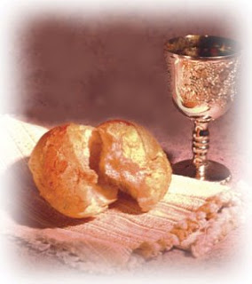
The Lord’s Supper is celebrated in the confession and gladness that, as our Lord says, He gives into our mouth not only bread and wine but His very body and blood to eat and drink for the forgiveness of sins and to strengthen our union with Him and with one another. Our Lord Jesus invites to His table those who trust His Words, repent of all sin, and set aside any refusal to forgive and love as He forgives and loves us, that they may show forth His death until He comes.

Whoever, therefore, eats the bread or drinks the blood of the Lord in an unworthy manner will be guilty concerning the body and blood of the Lord.
(1 Cor 11:28 ESV) Holy Communion is a confession of the faith which is confessed at this altar. Any who holds a confession differing from that of the Holy Scriptures, or are not a member in good standing with the LC-MS, are asked to speak with Pastor Sturzenbecher.

Members and guests of DSLC and School we stream our services through Facebook Live. With this stream we do publish this to our Facebook page which means your face may end up on our Facebook page. If you are not comfortable with this please talk to Pastor to address this concern. -Thank you, The AV Team.

594 God’s Own Child, I Gladly Say It 1st Service
1 God’s own child, I gladly say it:
I am baptized into Christ!
He, because I could not pay it,
Gave my full redemption price.
Do I need earth’s treasures many?
I have one worth more than any
That brought me salvation free
Lasting to eternity!

2 Sin, disturb my soul no longer:
I am baptized into Christ!
I have comfort even stronger:
Jesus’ cleansing sacrifice.
Should a guilty conscience seize me
Since my Baptism did release me
In a dear forgiving flood,
Sprinkling me with Jesus’ blood?

3 Satan, hear this proclamation:
I am baptized into Christ!
Drop your ugly accusation,
I am not so soon enticed.
Now that to the font I’ve traveled,
All your might has come unraveled,
And, against your tyranny,
God, my Lord, unites with me!

4 Death, you cannot end my gladness:
I am baptized into Christ!
When I die, I leave all sadness
To inherit paradise!
Though I lie in dust and ashes
Faith’s assurance brightly flashes:
Baptism has the strength divine
To make life immortal mine.

5 There is nothing worth comparing
To this lifelong comfort sure!
Open-eyed my grave is staring:
Even there I’ll sleep secure.
Though my flesh awaits its raising,
Still my soul continues praising:
I am baptized into Christ;
I’m a child of paradise!

507 Holy, Holy, Holy sts. 1–4 2nd Service
1 Holy, holy, holy! Lord God Almighty!
Early in the morning our song shall rise to Thee;
Holy, holy, holy, merciful and mighty!
God in three persons, blessèd Trinity!

2 Holy, holy, holy! All the saints adore Thee,
Casting down their golden crowns around the glassy sea;
Cherubim and seraphim falling down before Thee,
Which wert and art and evermore shalt be.

3 Holy, holy, holy! Though the darkness hide Thee,
Though the eye of sinful man Thy glory may not see,
Only Thou art holy; there is none beside Thee,
Perfect in pow’r, in love, and purity.

4 Holy, holy, holy! Lord God Almighty!
All Thy works shall praise Thy name in earth and sky and sea.
Holy, holy, holy, merciful and mighty!
God in three persons, blessèd Trinity!

Baptism 1st Service
Logan Brunmaier: Levi & Ashley Brunmaier

Invocation & Exhortation
P In the name of the Father and of the + Son and of the Holy Spirit.
C Amen.
C who made heaven and earth.
P I said, I will confess my transgressions unto the Lord,
C and You forgave the iniquity of my sin.

Confession and Absolution
P O almighty God, merciful Father,
C I, a poor, miserable sinner, confess unto You all my sins and iniquities with which I have ever offended You and justly deserved Your temporal and eternal punishment. But I am heartily sorry for them and sincerely repent of them, and I pray You of Your boundless mercy and for the sake of the holy, innocent, bitter sufferings and death of Your beloved Son, Jesus Christ, to be gracious and merciful to me, a poor, sinful being.
C Amen.

Introit
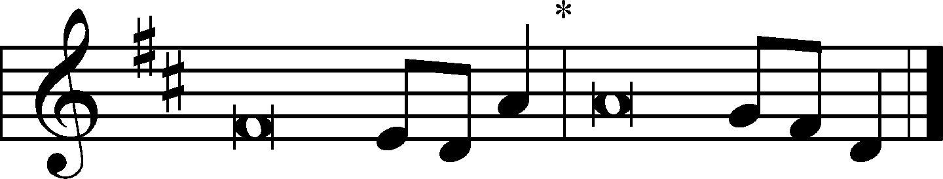
Blessèd be the Holy Trinity and the undivided | Unity.*
Let us give glory to him because he has shown his mer- | cy to us.
O | Lord, our Lord,*
how majestic is your name in | all the earth!
You have set your glory above the | heavens.*
Out of the mouth of babes and infants, you have es- | tablished strength.
When I look at your heavens, the work of your | fingers,*
the moon and the stars, which you have | set in place,
what is man that you are mind- | ful of him,*
and the son of man that you | care for him?
Yet you have made him a little lower than the heavenly | beings*
and crowned him with glory and | honor.
Glory be to the Father and | to the Son*
and to the Holy | Spirit;
as it was in the be- | ginning,*
is now, and will be forever. | Amen.
Blessèd be the Holy Trinity and the undivided | Unity.*
Let us give glory to him because he has shown his mer- | cy to us.

Gloria Patri
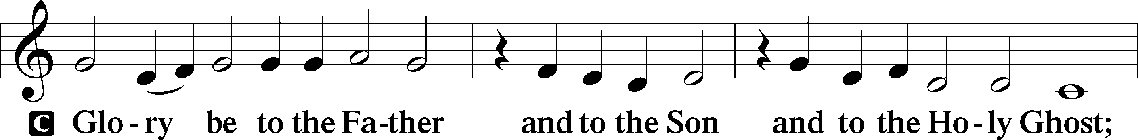
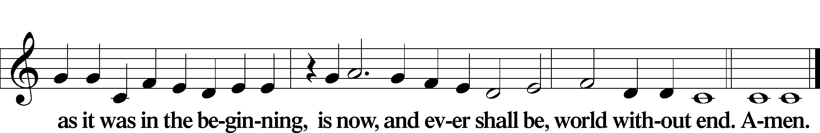
Kyrie LSB 186
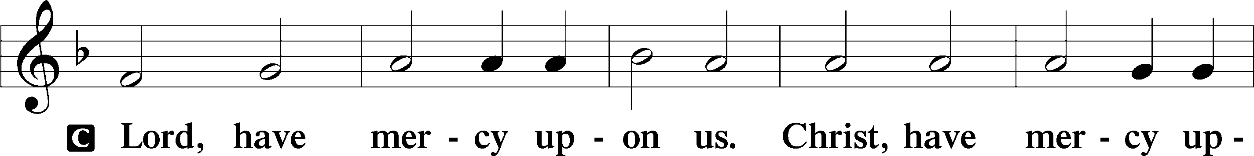
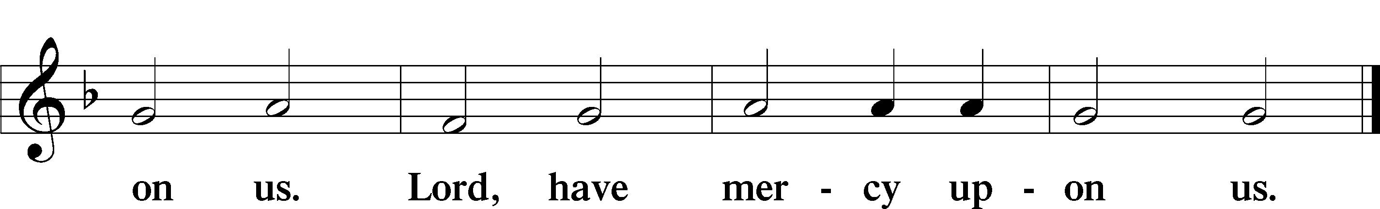

Gloria in Excelsis LSB 187
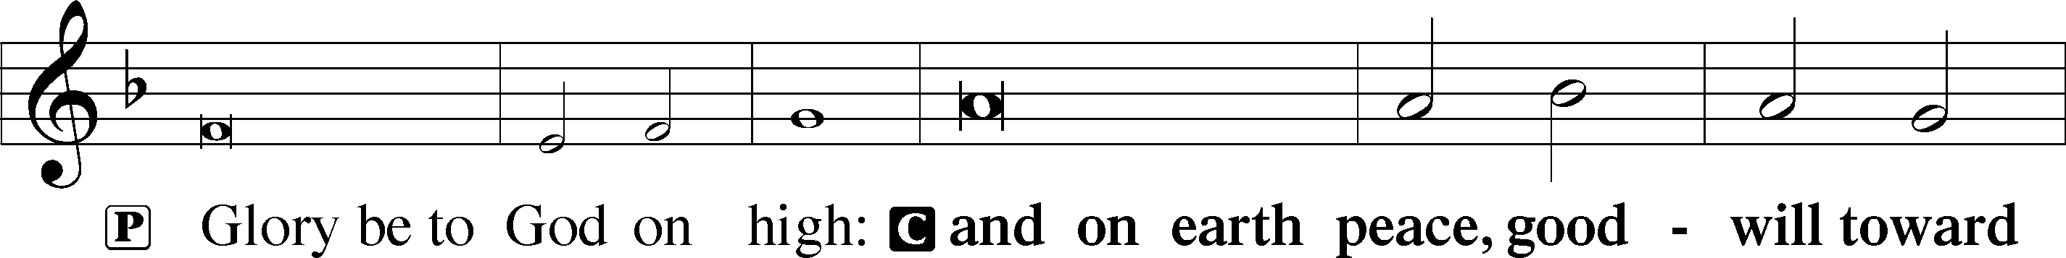
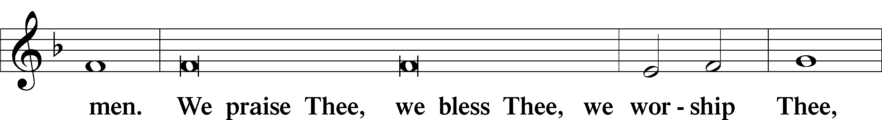
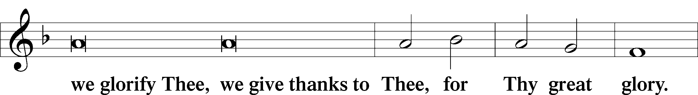
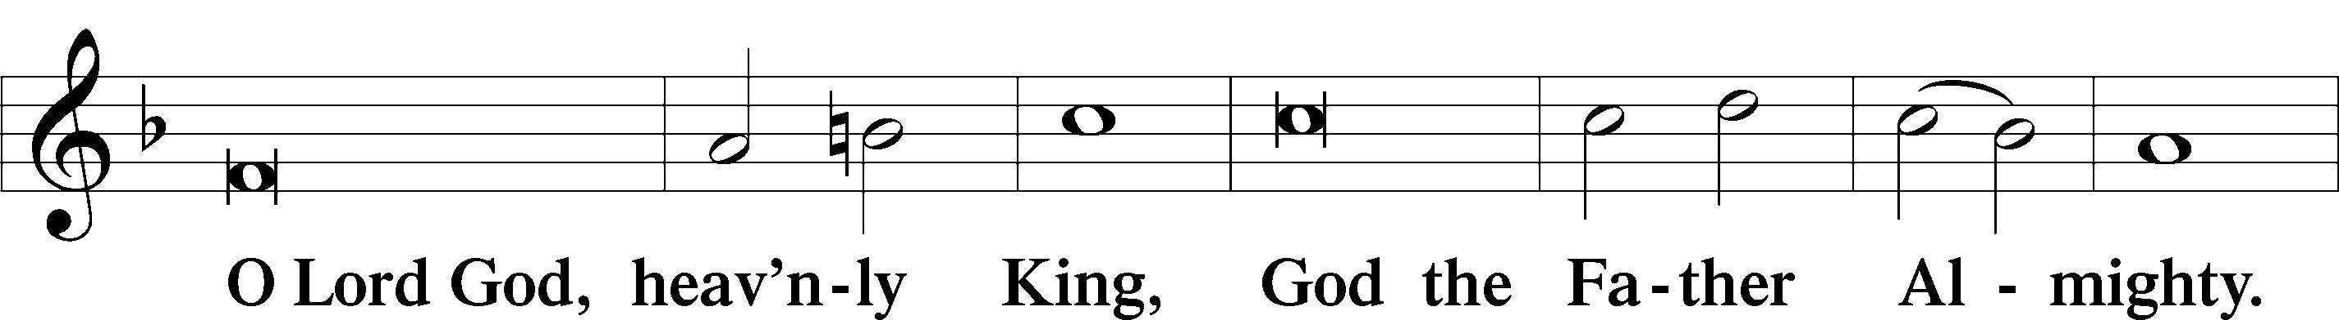
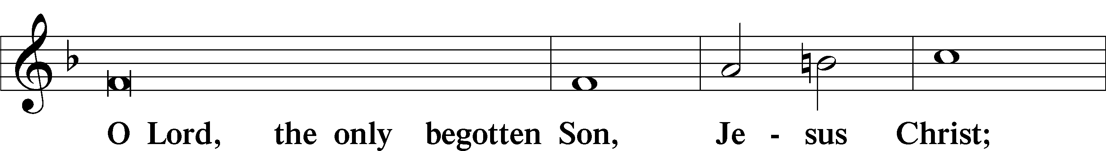
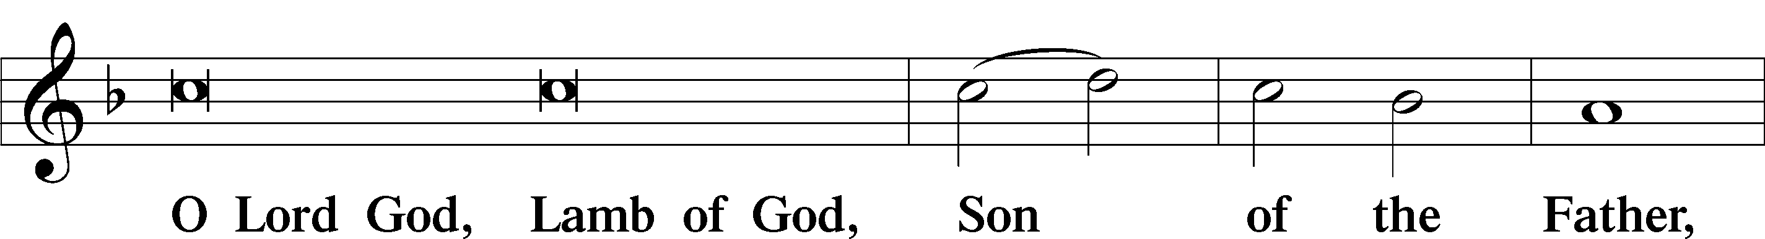
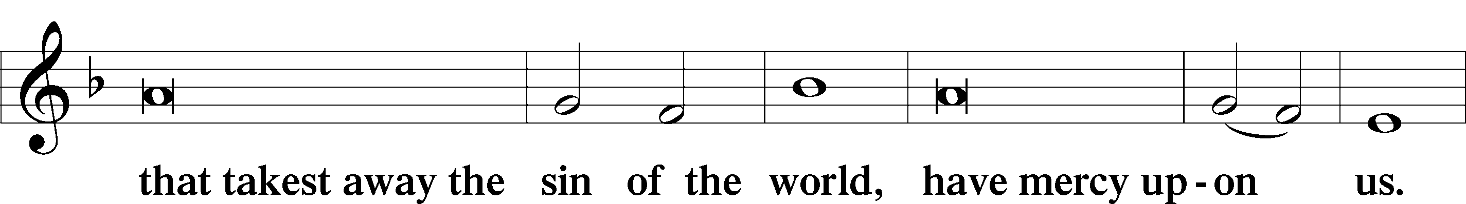
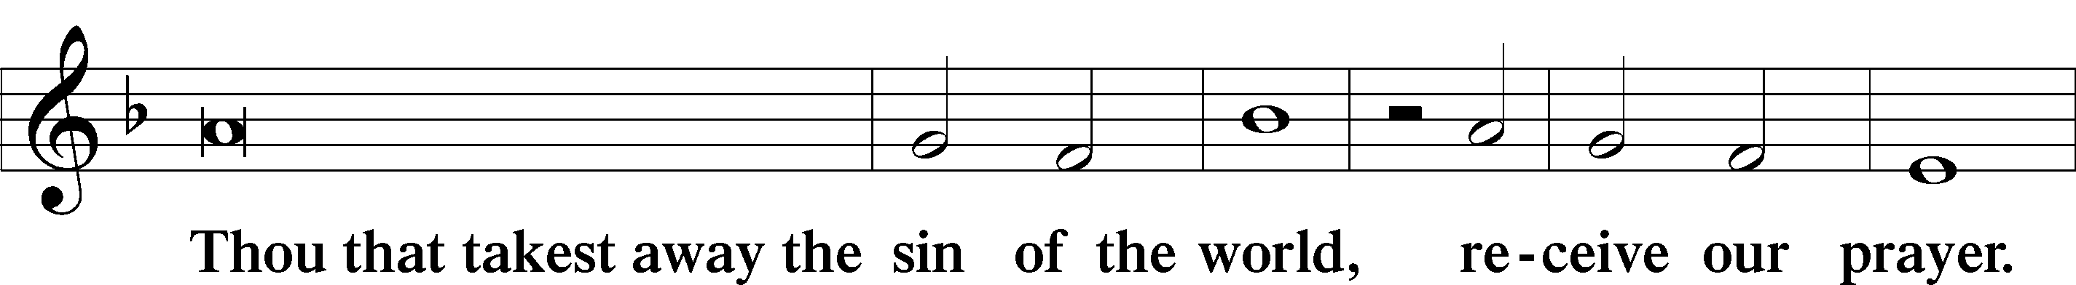
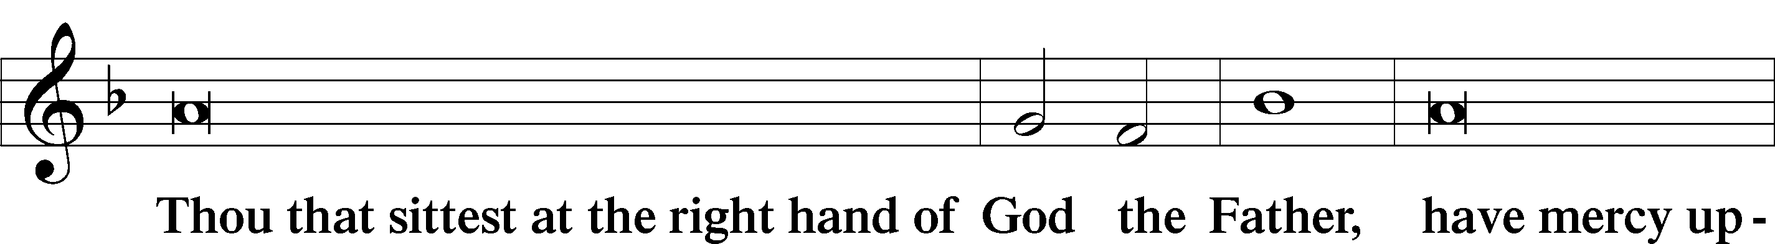
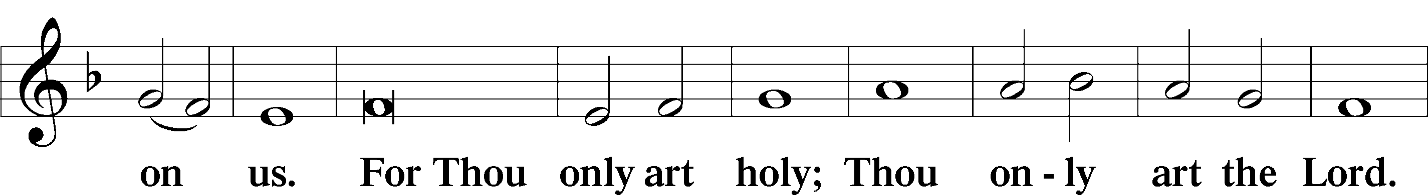
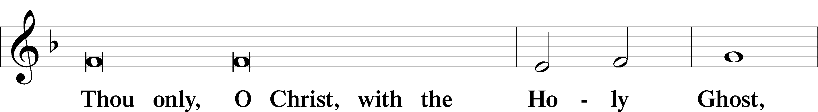
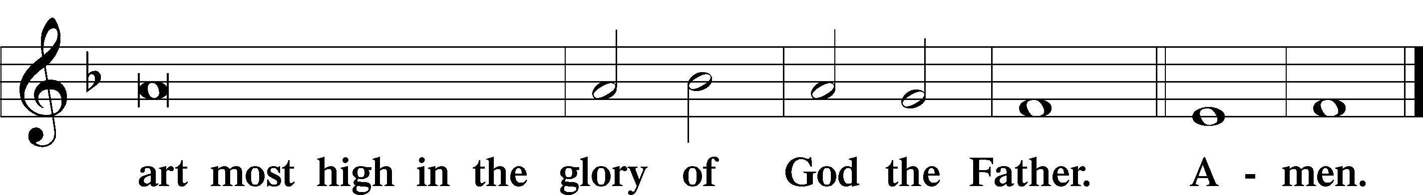

Salutation and Collect of the Day

Old Testament Reading Isaiah 6:1–7
¹In the year that King Uzziah died I saw the Lord sitting upon a throne, high and lifted up; and the train of his robe filled the temple. ²Above him stood the seraphim. Each had six wings: with two he covered his face, and with two he covered his feet, and with two he flew. ³And one called to another and said: “Holy, holy, holy is the Lord of hosts; the whole earth is full of his glory!” ⁴And the foundations of the thresholds shook at the voice of him who called, and the house was filled with smoke. ⁵And I said: “Woe is me! For I am lost; for I am a man of unclean lips, and I dwell in the midst of a people of unclean lips; for my eyes have seen the King, the Lord of hosts!” ⁶Then one of the seraphim flew to me, having in his hand a burning coal that he had taken with tongs from the altar. ⁷And he touched my mouth and said: “Behold, this has touched your lips; your guilt is taken away, and your sin atoned for.”

Catechetical Review
The Formula, Epitome, Summary 2
Right after the time of the apostles, and even while they were still living, false teachers and heretics arose. Therefore, symbols (brief, concise confessions) were written against the heretics in the Early Church. These symbols were regarded as the unanimous, universal Christian faith and confession of he orthodox and true Church. They are the Apostle’s Creed, the Nicene Cred, and the Athanasian Creed. We pledge ourselves to these symbols, and in this way, we reject all heresies and teachings that have been introduced into God’s Church against them.

Epistle Romans 11:33–36
³³Oh, the depth of the riches and wisdom and knowledge of God! How unsearchable are his judgments and how inscrutable his ways! ³⁴“For who has known the mind of the Lord, or who has been his counselor?” ³⁵“Or who has given a gift to him that he might be repaid?” ³⁶For from him and through him and to him are all things. To him be glory forever. Amen.

Alleluia LSB 190
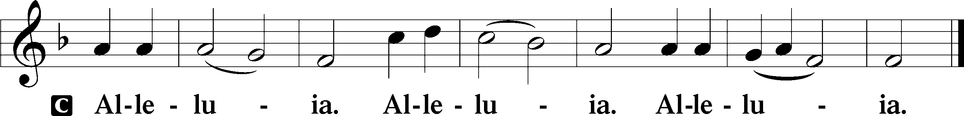

Holy Gospel John 3:1–17
¹Now there was a man of the Pharisees named Nicodemus, a ruler of the Jews. ²This man came to Jesus by night and said to him, “Rabbi, we know that you are a teacher come from God, for no one can do these signs that you do unless God is with him.” ³Jesus answered him, “Truly, truly, I say to you, unless one is born again he cannot see the kingdom of God.” ⁴Nicodemus said to him, “How can a man be born when he is old? Can he enter a second time into his mother’s womb and be born?” ⁵Jesus answered, “Truly, truly, I say to you, unless one is born of water and the Spirit, he cannot enter the kingdom of God. ⁶That which is born of the flesh is flesh, and that which is born of the Spirit is spirit. ⁷Do not marvel that I said to you, ‘You must be born again.’ ⁸The wind blows where it wishes, and you hear its sound, but you do not know where it comes from or where it goes. So it is with everyone who is born of the Spirit.” ⁹Nicodemus said to him, “How can these things be?” ¹⁰Jesus answered him, “Are you the teacher of Israel and yet you do not understand these things? ¹¹Truly, truly, I say to you, we speak of what we know, and bear witness to what we have seen, but you do not receive our testimony. ¹²If I have told you earthly things and you do not believe, how can you believe if I tell you heavenly things? ¹³No one has ascended into heaven except he who descended from heaven, the Son of Man. ¹⁴And as Moses lifted up the serpent in the wilderness, so must the Son of Man be lifted up, ¹⁵that whoever believes in him may have eternal life. ¹⁶“For God so loved the world, that he gave his only Son, that whoever believes in him should not perish but have eternal life. ¹⁷For God did not send his Son into the world to condemn the world, but in order that the world might be saved through him.”

Athanasian Creed
C Whoever desires to be saved must, above all, hold the catholic faith.
Whoever does not keep it whole and undefiled will without doubt perish eternally.
And the catholic faith is this,
that we worship one God in Trinity and Trinity in Unity, neither confusing the persons nor dividing the substance.
For the Father is one person, the Son is another, and the Holy Spirit is another.
But the Godhead of the Father and of the Son and of the Holy Spirit is one: the glory equal, the majesty coeternal.
Such as the Father is, such is the Son, and such is the Holy Spirit:
the Father uncreated, the Son uncreated, the Holy Spirit uncreated;
the Father infinite, the Son infinite, the Holy Spirit infinite;
the Father eternal, the Son eternal, the Holy Spirit eternal.
And yet there are not three Eternals, but one Eternal,
just as there are not three Uncreated or three Infinites, but one Uncreated and one Infinite.
In the same way, the Father is almighty, the Son almighty, the Holy Spirit almighty;
and yet there are not three Almighties, but one Almighty.
So the Father is God, the Son is God, the Holy Spirit is God;
and yet there are not three Gods, but one God.
So the Father is Lord, the Son is Lord, the Holy Spirit is Lord;
and yet there are not three Lords, but one Lord.
Just as we are compelled by the Christian truth to acknowledge each distinct person as God and Lord, so also are we prohibited by the catholic religion to say that there are three Gods or Lords.
The Father is not made nor created nor begotten by anyone.
The Son is neither made nor created, but begotten of the Father alone.
The Holy Spirit is of the Father and of the Son, neither made nor created nor begotten, but proceeding.
Thus, there is one Father, not three Fathers; one Son, not three Sons; one Holy Spirit, not three Holy Spirits.
And in this Trinity none is before or after another; none is greater or less than another;
but the whole three persons are coeternal with each other and coequal, so that in all things, as has been stated above, the Trinity in Unity and Unity in Trinity is to be worshiped.
Therefore, whoever desires to be saved must think thus about the Trinity.
But it is also necessary for everlasting salvation that one faithfully believe the incarnation of our Lord Jesus Christ.
Therefore, it is the right faith that we believe and confess that our Lord Jesus Christ, the Son of God, is at the same time both God and man.
He is God, begotten from the substance of the Father before all ages; and He is man, born from the substance of His mother in this age:
perfect God and perfect man, composed of a rational soul and human flesh;
equal to the Father with respect to His divinity, less than the Father with respect to His humanity.
Although He is God and man, He is not two, but one Christ:
one, however, not by the conversion of the divinity into flesh, but by the assumption of the humanity into God;
one altogether, not by confusion of substance, but by unity of person.
For as the rational soul and flesh is one man, so God and man is one Christ,
who suffered for our salvation, descended into hell, rose again the third day from the dead,
ascended into heaven, and is seated at the right hand of the Father, God Almighty, from whence He will come to judge the living and the dead.
At His coming all people will rise again with their bodies and give an account concerning their own deeds.
And those who have done good will enter into eternal life, and those who have done evil into eternal fire.
This is the catholic faith; whoever does not believe it faithfully and firmly cannot be saved.

802 Immortal, Invisible, God Only Wise
1 Immortal, invisible,
God only wise,
In light inaccessible
hid from our eyes,
Most blessèd, most glorious,
the Ancient of Days,
Almighty, victorious,
Thy great name we praise.

2 Unresting, unhasting,
and silent as light,
Nor wanting, nor wasting,
Thou rulest in might;
Thy justice like mountains
high soaring above
Thy clouds which are fountains
of goodness and love.

3 To all life Thou givest—
to both great and small—
In all life Thou livest,
the true Life of all;
We blossom and flourish
as leaves on the tree
And wither and perish—
but naught changes Thee.

4 Great Father of glory,
pure Father of light,
Thine angels adore Thee,
all veiling their sight;
All laud we would render:
O help us to see
’Tis only the splendor
of light that hides Thee.
Text: W. Chalmers Smith, 1824–1908, alt.
Text: Public domain

Sermon

Offertory LSB 192
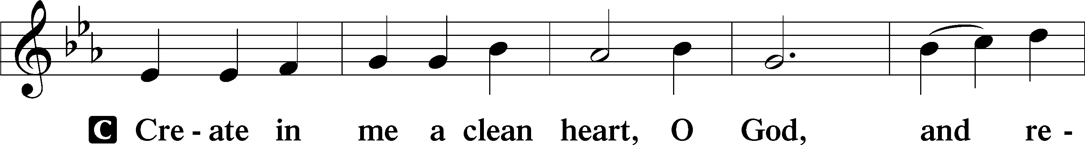
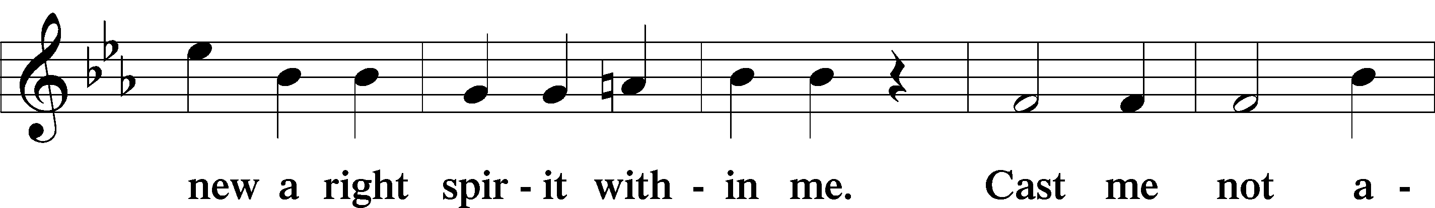
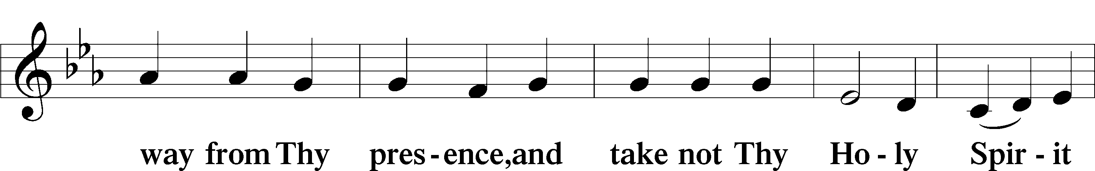
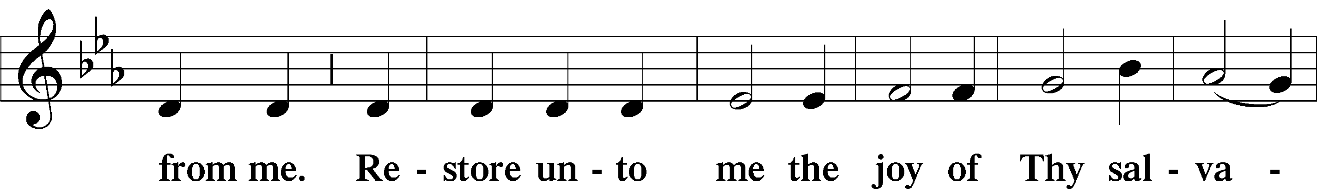
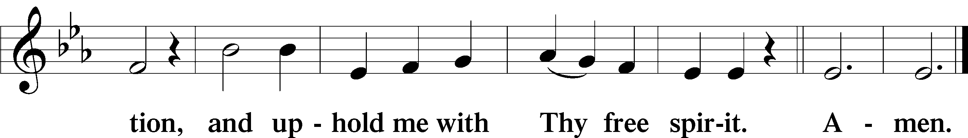

Prayer of the Church “Hear Our Prayer“

Preface LSB 194

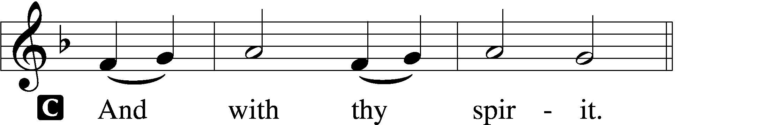


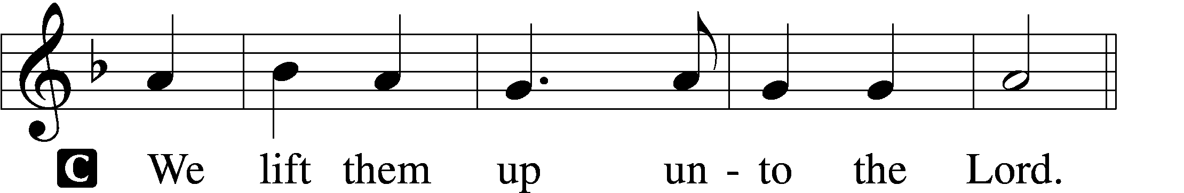

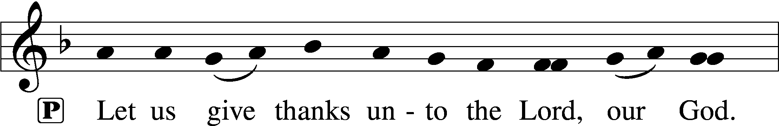
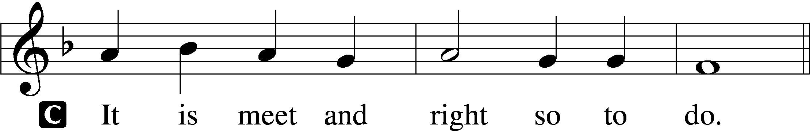

Sanctus LSB 195
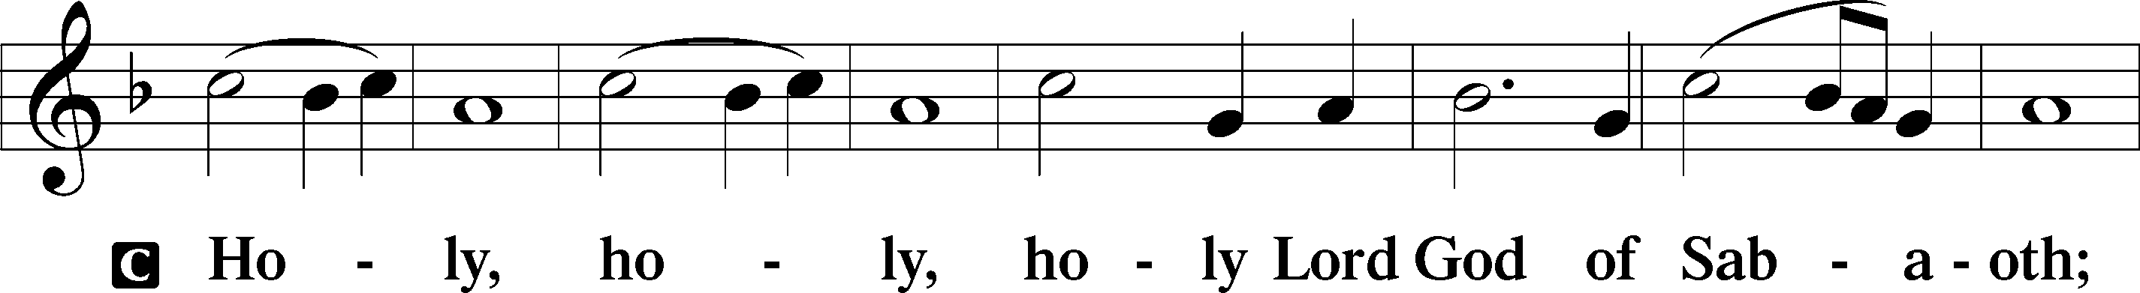
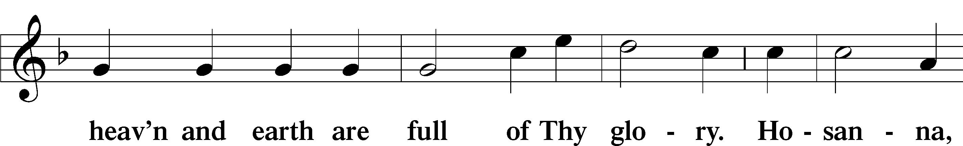
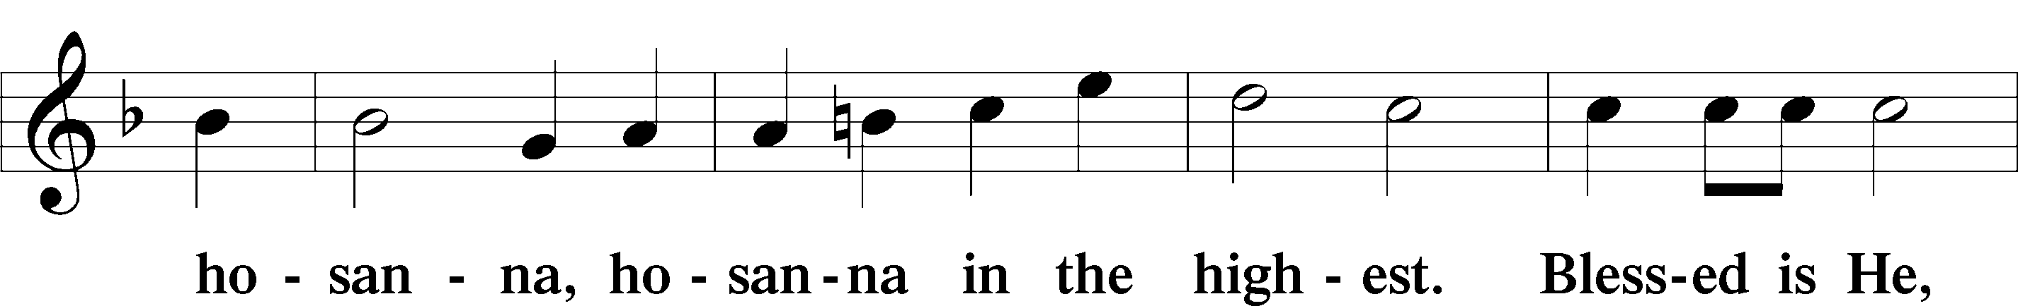
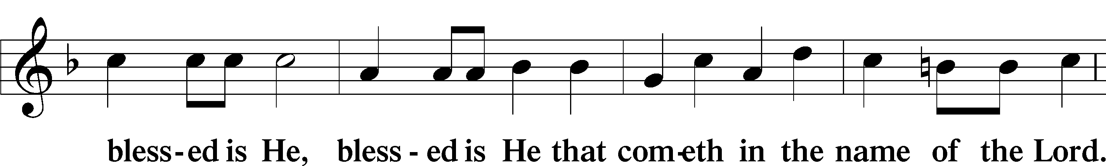
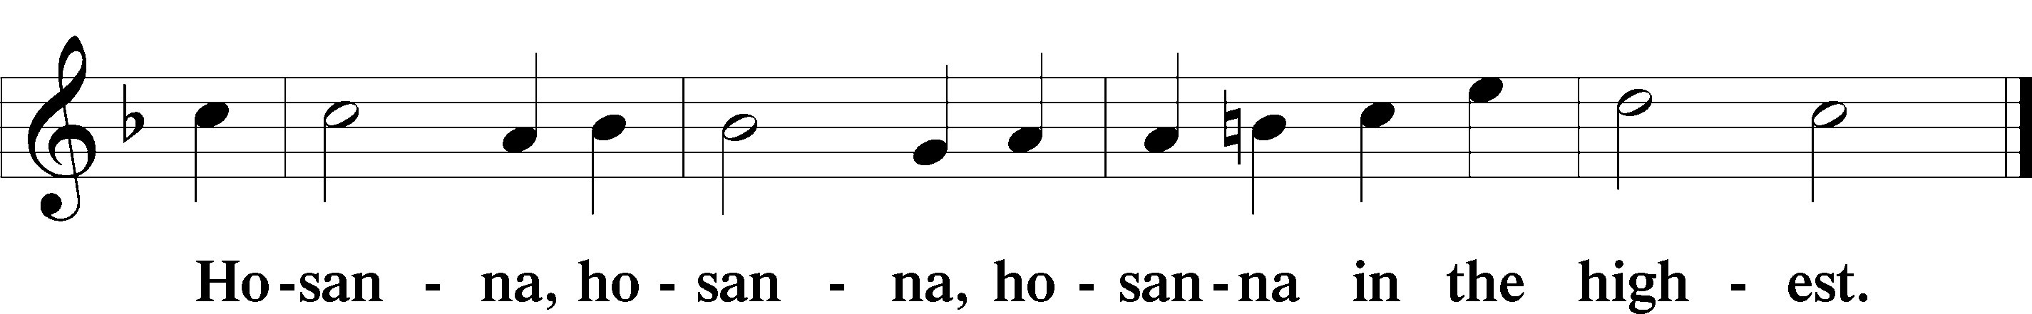

Lord’s Prayer LSB 196
The Words of Our Lord LSB 197

Pax Domini LSB 197
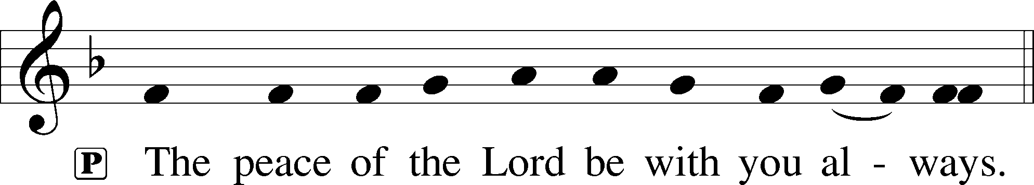

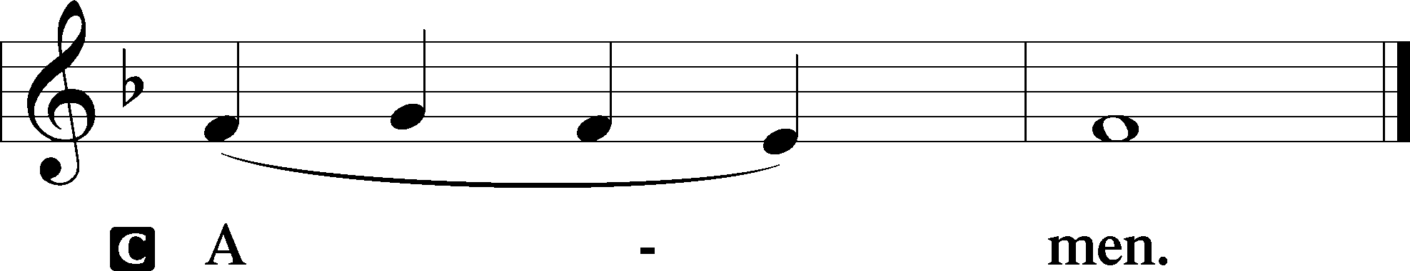

Agnus Dei LSB 198
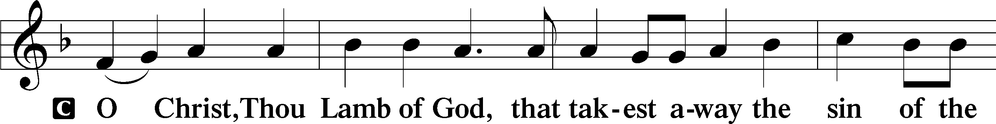
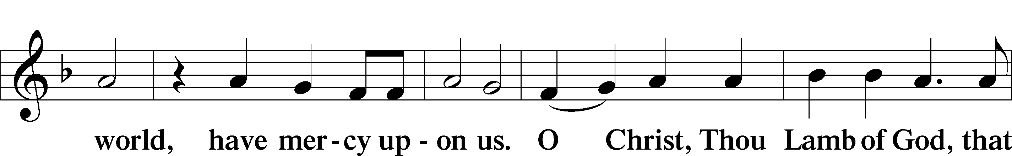
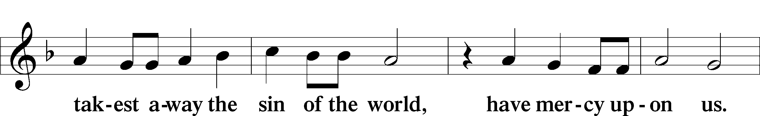
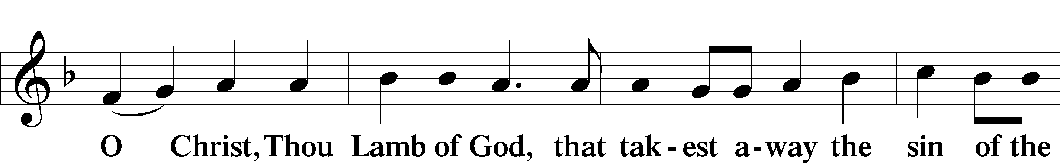
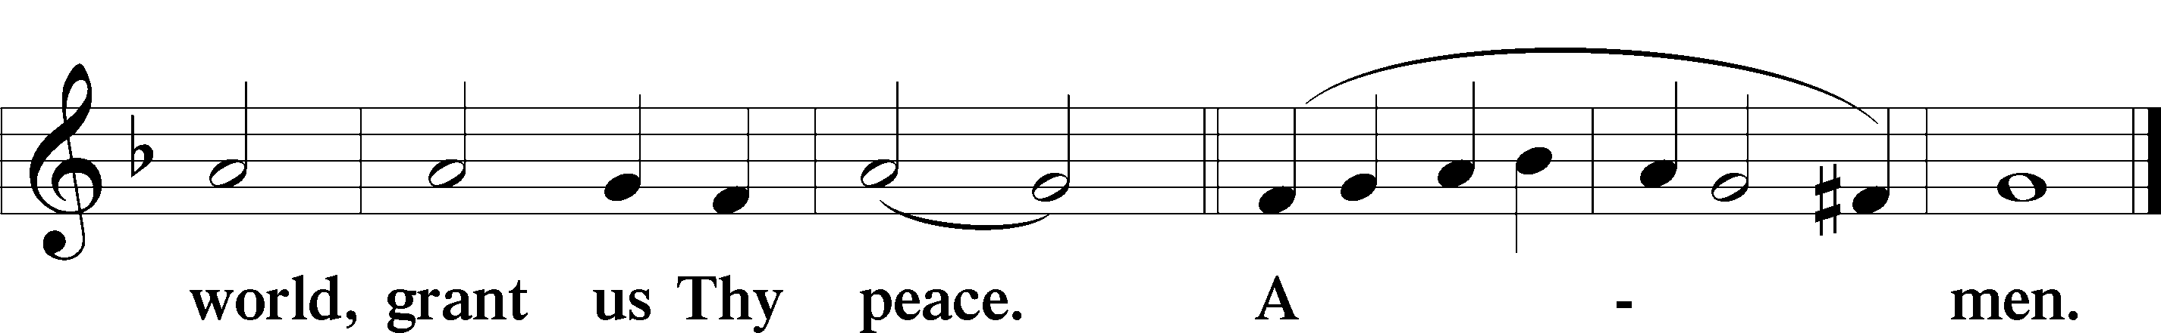

571 God Loved the World So That He Gave
1 God loved the world so that He gave
His only Son the lost to save,
That all who would in Him believe
Should everlasting life receive.

2 Christ Jesus is the ground of faith,
Who was made flesh and suffered death;
All then who trust in Him alone
Are built on this chief cornerstone.

3 God would not have the sinner die;
His Son with saving grace is nigh;
His Spirit in the Word declares
How we in Christ are heaven’s heirs.

4 Be of good cheer, for God’s own Son
Forgives all sins which you have done;
And, justified by Jesus’ blood,
Your Baptism grants the highest good.

5 If you are sick, if death is near,
This truth your troubled heart can cheer:
Christ Jesus saves your soul from death;
That is the firmest ground of faith.

D 6 Glory to God the Father, Son,
And Holy Spirit, Three in One!
To You, O blessèd Trinity,
Be praise now and eternally!

761 Rock of Ages, Cleft for Me
1 Rock of Ages, cleft for me,
Let me hide myself in Thee;
Let the water and the blood,
From Thy riven side which flowed,
Be of sin the double cure:
Cleanse me from its guilt and pow’r.

2 Not the labors of my hands
Can fulfill Thy Law’s demands;
Could my zeal no respite know,
Could my tears forever flow,
All for sin could not atone;
Thou must save, and Thou alone.

3 Nothing in my hand I bring;
Simply to Thy cross I cling.
Naked, come to Thee for dress;
Helpless, look to Thee for grace;
Foul, I to the fountain fly;
Wash me, Savior, or I die.

4 While I draw this fleeting breath,
When mine eyelids close in death,
When I soar to worlds unknown,
See Thee on Thy judgment throne,
Rock of Ages, cleft for me,
Let me hide myself in Thee.

680 Thine the Amen, Thine the Praise
1 Thine the amen Thine the praise
Alleluias angels raise
Thine the everlasting head
Thine the breaking of the bread
Thine the glory Thine the story
Thine the harvest then the cup
Thine the vineyard then the cup is lifted up lifted up.

2 Thine the life eternally
Thine the promise let there be
Thine the vision Thine the tree
All the earth on bended knee
Gone the nailing gone the railing
Gone the pleading gone the cry
Gone the sighing gone the dying what was loss lifted high.

3 Thine the truly Thine the yes
Thine the table we the guest
Thine the mercy all from Thee
Thine the glory yet to be
Then the ringing and the singing
Then the end of all the war
Thine the living Thine the loving evermore evermore.

4 Thine the kingdom Thine the prize
Thine the wonder full surprise
Thine the banquet then the praise
Then the justice of Thy ways
Thine the glory Thine the story
Then the welcome to the least
Then the wonder all increasing at Thy feast at Thy feast.

5 Thine the glory in the night
No more dying only light
Thine the river Thine the tree
Then the Lamb eternally
Then the holy holy holy
Celebration jubilee
Thine the splendor Thine the brightness only Thee only Thee.

Nunc Dimittis LSB 199
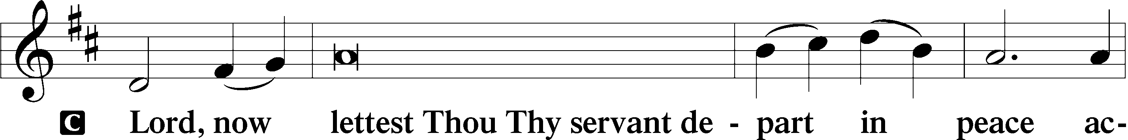
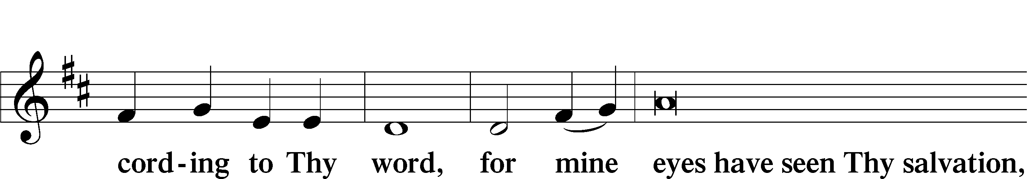
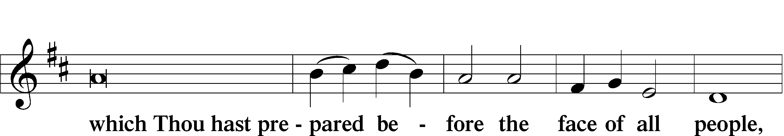
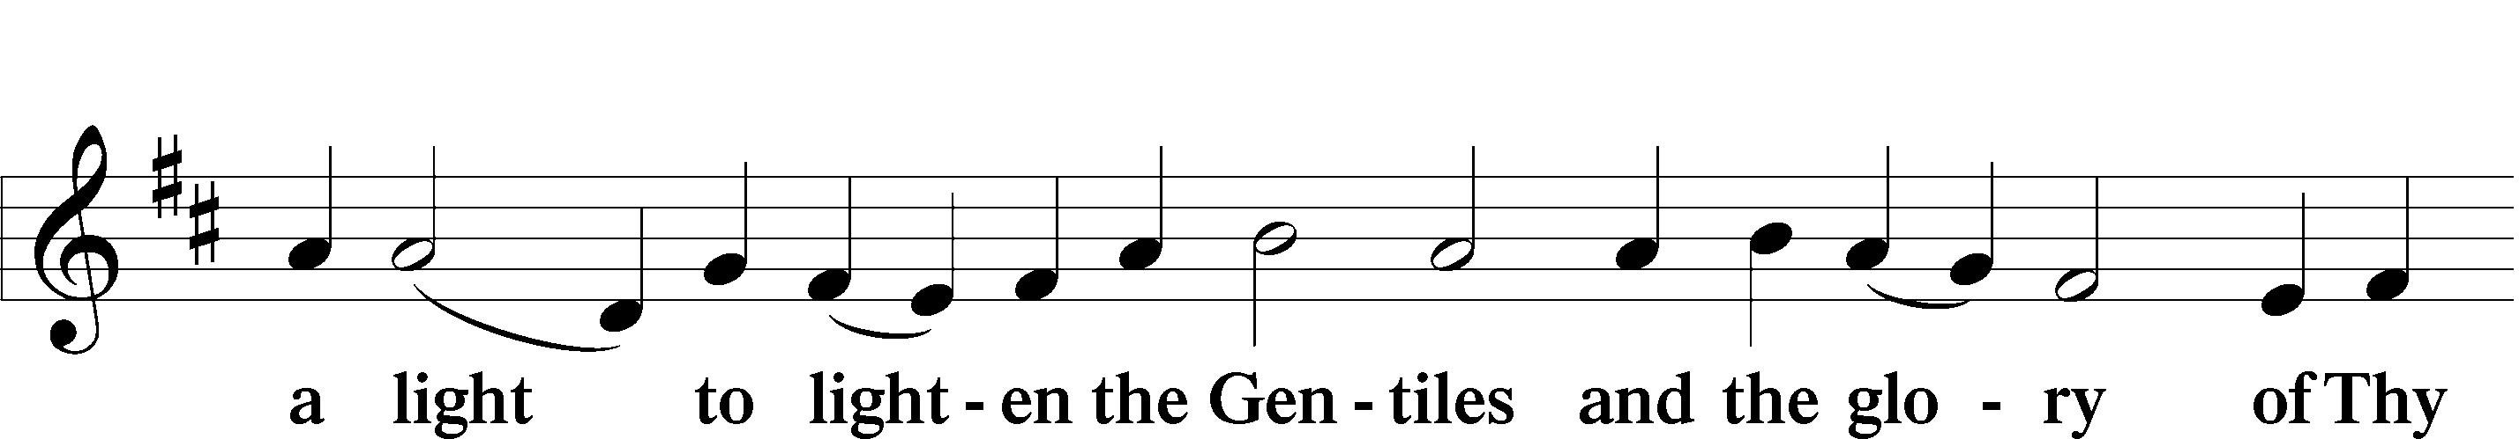
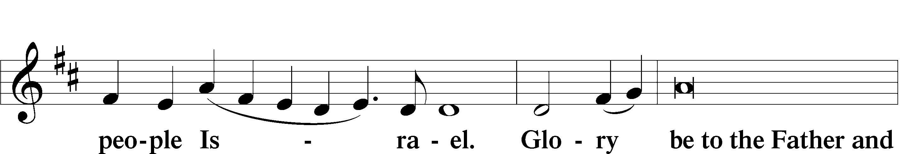
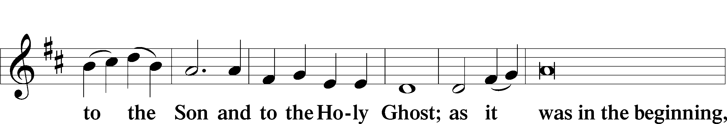
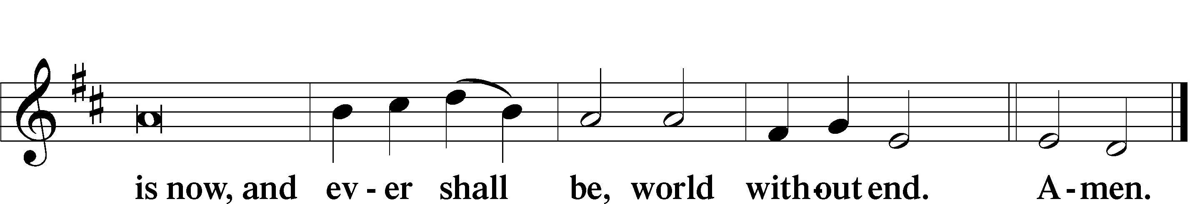

Thanksgiving LSB 200
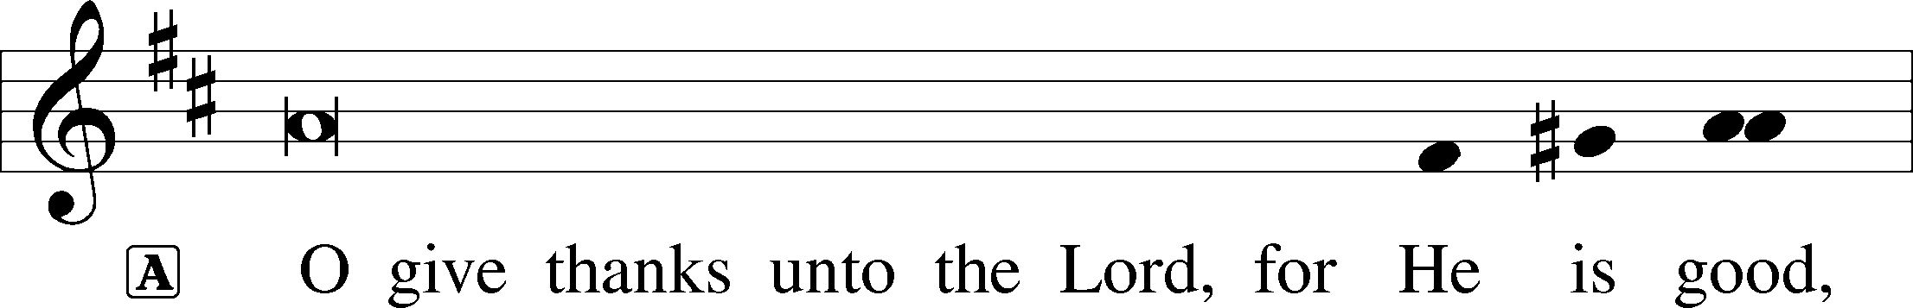

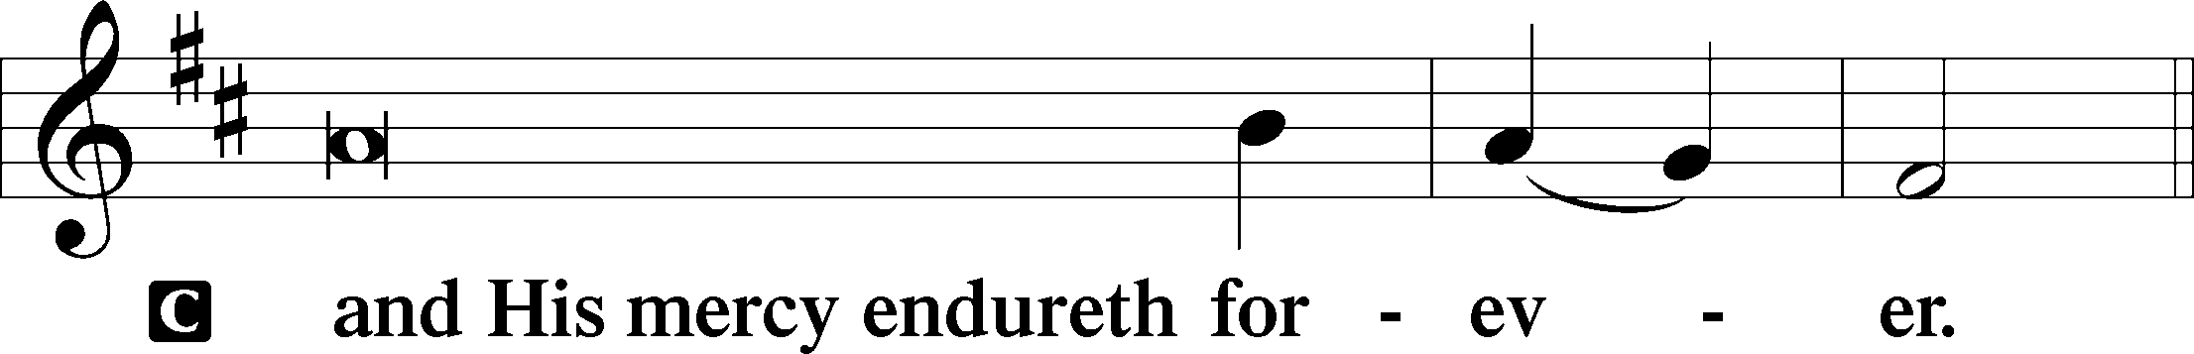

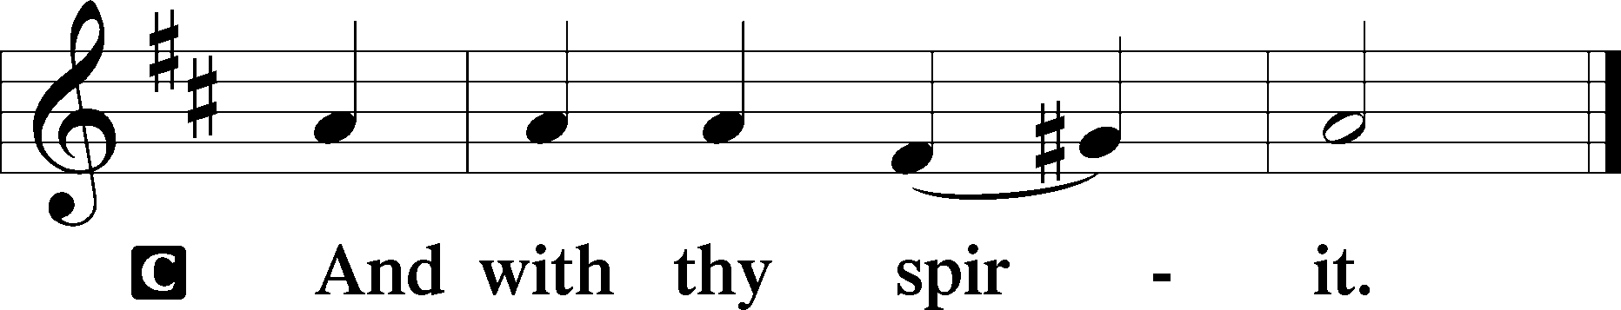
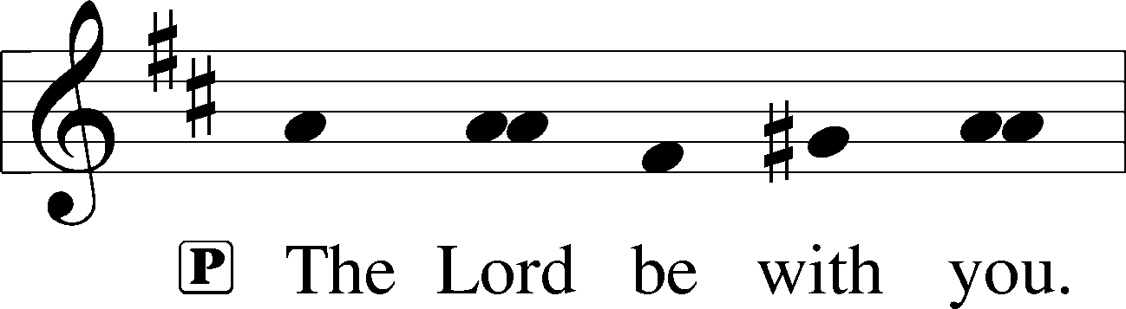

Benedicamus & Benediction

966 Before You, Lord, We Bow
1 Before You, Lord, we bow,
Our God who reigns above
And rules the world below,
Boundless in pow’r and love.
Our thanks we bring
In joy and praise,
Our hearts we raise
To You, our King!

2 The nation You have blest
May well Your love declare,
From foes and fears at rest,
Protected by Your care.
For this bright day,
For this fair land—
Gifts of Your hand—
Our thanks we pay.

3 May ev’ry mountain height,
Each vale and forest green,
Shine in Your Word’s pure light,
And its rich fruits be seen!
May ev’ry tongue
Be tuned to praise
And join to raise
A grateful song.

4 Earth, hear your Maker’s voice;
Your great Redeemer own;
Believe, obey, rejoice,
And worship Him alone.
Cast down your pride,
Your sin deplore,
And bow before
The Crucified.

5 And when in pow’r He comes,
Oh, may our native land
From all its rending tombs
Send forth a glorious band,
A countless throng,
With joy to sing
To heav’n’s high King
Salvation’s song!

